family.fitness.faith.fun

How can I serve others?

A vaccine for isolated days!
Help your family be fit and healthy, stay connected, and grow in character.
WEEK
1

www.family.fit

How to make fitness an important
part of your family’s life:

Make it fun
- Be active together
Do exercise a few times a week.
Find a time that will work for everyone.

- Play games
- Involve everyone in the household
- Go inside or outside
- Be creative and improvise with what you have

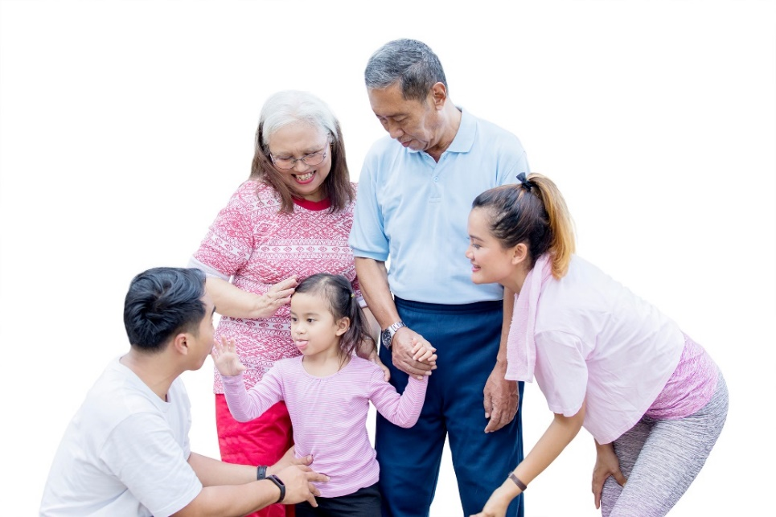

Challenge each other
- Allow different levels of challenge according to ability, size and age
Set personal
goals.
Compare improvements with your personal best.
- Respect each other
- Listen actively
- Share family.fit! It’s free.
- Don’t do exercises that cause pain or make any existing pain worse.
- Don’t exercise if you are sick. Wash hands before and after family.fit.
IMPORTANT AGREEMENT BEFORE USING THIS RESOURCE
By using this resource you agree to our Terms and Conditions https:/family.fit/terms-and-conditions/ as detailed in full on our website. These govern your use of this resource by you and all those exercising with you. Please ensure that you and all those exercising with you accept these terms and conditions in full. If you disagree with these terms and conditions or any part of these terms and conditions, you must not use this resource.
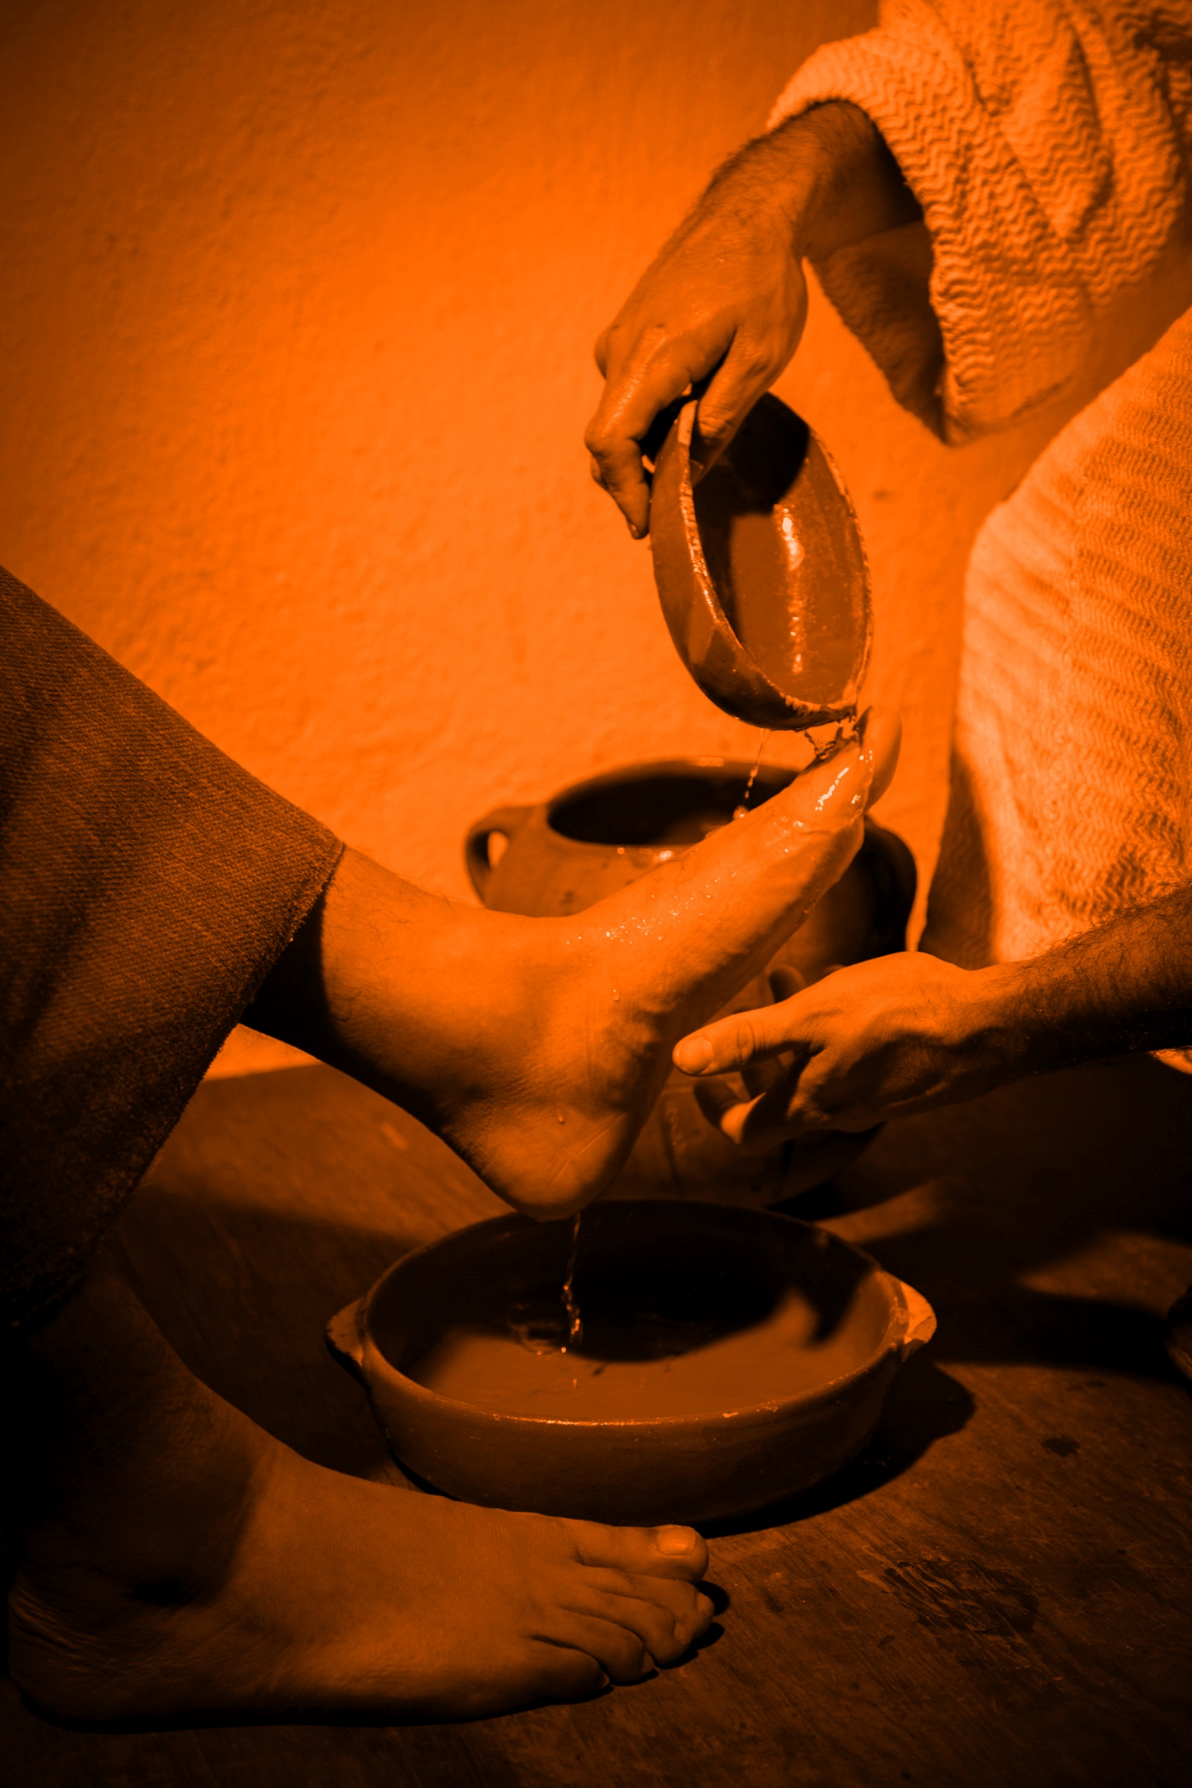

This Week

Theme: Serving others
How this works
As a family, do some physical exercise 3 days a week (though even once is helpful!). If you can do it more often, then do other types of exercise too – walking, jogging, riding, skating, or swimming.
Each week of family.fit has a theme. The focus this week is serving others. Each step below helps you explore the theme together.
Each session is an adventure made up of 7 steps.
There are 3 options for each step, giving 3 days of exercise programming.
7 Steps of family.fit
- Warm-up
- Talk
- Move
- Challenge
- Explore
- Pray
- Play

Remember anyone in the household can take the phone and lead a different step in the adventure.
Have fun together!

Step 1 | Warm-up

Start moving the whole body 5 min
Do the following whole body warm-ups.
Warm-up to music
DAY 1
Do the following (then repeat):
20 jumping jacks
20 ski jumps
10 push-ups against a wall/fence
10 high jumps
See the Warm-up video.
Follow the leader
DAY 2
2
Go for a short jog around the house or yard while everyone follows a chosen leader. Try to go to every room or space.
The leader can change movements, eg. side steps or high knees. Swap leaders.
Warm-up to music
DAY 3

Do the following (then repeat):
Running on the spot
Ski jumps
Sit-ups
High knees running

Step 2 | Talk together

Rest and start a conversation 5 min
Sit down together and start a conversation. Here are some questions to get you started.
Discuss
DAY 1
What does it mean to ‘serve’ someone?
What are some examples of how you have served someone in your family this week?
Has someone in your family served you this week?
Discuss
DAY 2
2
What are some examples of how you have served someone at school, at your work, or in your community this week?
Talk about how someone outside your home has served you.
Discuss
DAY 3

Describe some of your feelings when you were able to serve someone.
When someone served you?
Which made you feel better?

Step 3 | Move

Move and do squats 5 min
Learn and practice squats to help your leg and core muscles.
Practice the squat
DAY 1
DAY 2
2
DAY 3

Watch Squats video.
Practice this movement in pairs. Start slowly and carefully.
Bend low and collect objects
Do the following race: Scatter 15 random objects on the floor. Take turns to run and bend low to collect all the objects. Place them in a bucket in the middle of the room. Who can collect them all in less than 30 seconds? See if you can get a personal best.
Try other types of squats
See Squats Development video.
Practice them together.
Do jumping squats.
Do back to back squats.

Step 4 | Challenge

Move in a family challenge 10 min
Challenging each other helps give you energy.
Family challenge
DAY 1
Watch video Family Challenge.
Stand in a circle facing each other. Do 50 squats as a family. One person starts to do squat repetitions. Tap out to the next person when you need a break.
After 50 squats, run as a family to a marker and back. Run to pace of slowest runner. Then start squats again. Do three rounds of 50.
Tabata
DAY 2
2
Listen to the Tabata music. Everyone runs on the spot for 20 seconds then rests for 10 seconds. Everyone squats for 20 seconds then rests for 10 seconds. Repeat 4 times.
See Tabata Video.
Family challenge
DAY 3

Repeat the squat activity from Day 1.

Step 5 | Explore

Explore the Bible together 5 min
Explore the Life Question - “How can I serve others?” Read the story from John 13 (next page).
Read and discuss together
DAY 1
Read today’s story together.
Washing the feet of a visitor was a custom during the time of Jesus. Why did it happen? What did it reveal about the owner of the home?
Describe your feelings if you were there and someone washed your feet.
Reread and discuss together
DAY 2
2
Choose roles and act out the story. Jesus said, “I’ve laid down a pattern for you. What I’ve done, you do”. What did this mean for His disciples?
Memorize these words and encourage each other to remember and live them.
Reread the Bible verse
DAY 3

Washing someone’s feet was a normal thing when this story took place. Talk about some of the ways that you can ‘wash the feet of others’ today and in the days ahead.
Describe your feelings as you washed others and had your feet washed?
What can you do together as a family to serve others?

A story about serving
The following is a story of Jesus from chapter 13 of the Book of John in the Bible. If you want to read the whole story look in a Bible or visit BibleGateway (or download the Bible App).
Jesus got up from the meal table, set aside his robe, and put on an apron. Then he poured water into a basin and began to wash the feet of the disciples, drying them with his apron.
Then he said, “Do you understand what I have done to you? You address me as ‘Teacher’ and ‘Master,’ and rightly so. That is what I am. So if I, the Master and Teacher, washed your feet, you must now wash each other’s feet. I’ve laid down a pattern for you. What I’ve done, you do. I’m only pointing out the obvious. A servant is not ranked above his master; an employee doesn’t give orders to the employer. If you understand what I’m telling you, act like it—and live a blessed life.
(John 13:4-5,12-17 MSG)

Step 6 | Pray

Pray and cool down 5 min
Take time to look outwards and pray for others.
Stretching prayers
DAY 1
Look at the video on stretching and complete some of the body stretches.
Pray for each other as you stretch.
Pray for friends or neighbors
DAY 2
2
Think of family friends or neighbors. Imagine what their needs might be.
Pray for them. Then call or send a message to encourage them.
Cooking and Nutrition
DAY 3

Choose a vegetable or fruit that your family enjoys (e.g. a banana or carrot). Eat it together after the workout.
Pray and give thanks for this fruit or vegetable and the happiness it brings.
Make a poster of what you love about this fruit or vegetable. Find out why it is good for the body.
Look for recipes with it and cook some meals or snacks. Enjoy eating them and share with your neighbors.

Step 7 | Play together

Play games as a family 5 min
Play together in active challenges (involving agility, speed and cardio) and quiet games.
Squat and run
DAY 1
One person is the runner while another does squats. The runner moves objects from one bucket to another about 5m apart. The other person does squats until the runner is finished. Then the runner calls someone new, and the person squatting becomes the runner.
See Game video.
Play a quiet game
DAY 2
2
Play a board game familiar to the family. Have fun!
Ninja course
DAY 3

Set up a simple course to follow. Use the space you have inside or outside (e.g. run to the tree/chair, leap over the path/rug, etc.) Be creative!
Take turns to get through the Ninja course as quickly as possible. Use a stopwatch to time each person.
Watch Ninja Video.

Terminology
- A warm-up is a simple action that gets muscles warm, breathing deeper, and blood pumping. Play fun, up-tempo music for your warm-up activities. Do a range of movements for 3-5 minutes.
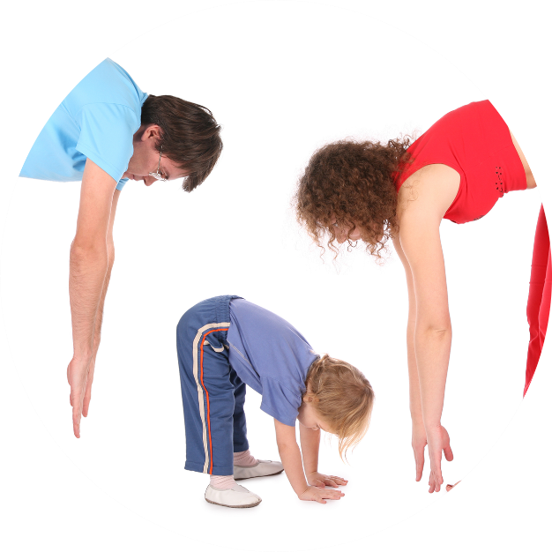
- Workout movements can be seen on the videos so you can learn the new exercise and practice it well. Starting slowly with a focus on technique will enable you to go faster and stronger later.
- Stretches are less likely to cause injury when done AFTER warm-ups. Use a slower piece of music to do stretches. Stretch gently – and hold for 5 seconds.
- Rest and recover after energetic movement. Conversation is great here.
- Tap out is a way to pass the exercise on to the next person. You can choose different ways to “tap out” e.g. hand clap, whistle, finger guns, wink etc. You make it up!

Video links
Find all the videos for family.fit at https://family.fit/ or at the family.fit YouTube® channel

family.fit promo video
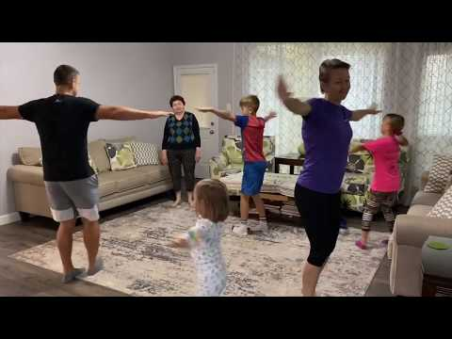
family.fit video
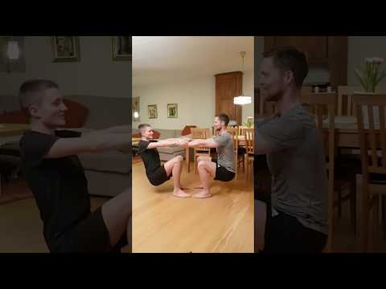
family.fit mobile video

Please Stay Connected
We hope you have enjoyed this first booklet of family.fit. This has been put together by volunteers from around the world. You will find all new family.fit sessions on the website https://family.fit
The website has the latest information, ways you can feedback your thoughts and is the place to stay connected with family.fit!
If you enjoyed this, please share with your friends and others you know who might like to participate.
This resource is given freely and meant to be freely given to others at no cost.
If you translate this into your language, please share it back on the website or email it to info@family.fit so it can be shared with others.
Thank you.
The family.fit team

Web: www.family.fit
Email: info@family.fit

