family.fitness.faith.fun

How can I develop courage?

A vaccine for isolated days!
Help your family be fit and healthy, stay connected, and grow in character.
2
WEEK

www.family.fit
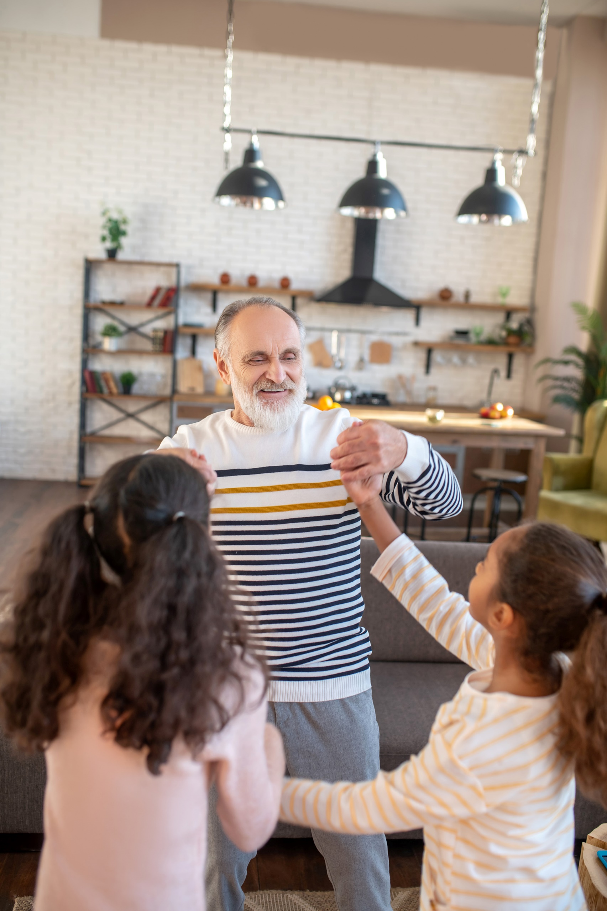

How to make fitness
an important part of your family’s life:

Make it fun
- Be active together
Do exercise a few times a week.
Find a time that will work for everyone.

- Play games
- Involve everyone in the household
- Go inside or outside
- Be creative and improvise with what you have

Challenge each other
- Allow different levels of challenge according to ability, size and age
Set personal
goals.
Compare improvements with your personal best.
- Respect each other
- Listen actively
- Share family.fit! It’s free.
- Don’t do exercises that cause pain or make any existing pain worse.
- Don’t exercise if you are sick. Wash hands before and after family.fit.
IMPORTANT AGREEMENT BEFORE USING THIS RESOURCE
By using this resource you agree to our Terms and Conditions https:/family.fit/terms-and-conditions/ as detailed in full on our website. These govern your use of this resource by you and all those exercising with you. Please ensure that you and all those exercising with you accept these terms and conditions in full. If you disagree with these terms and conditions or any part of these terms and conditions, you must not use this resource.
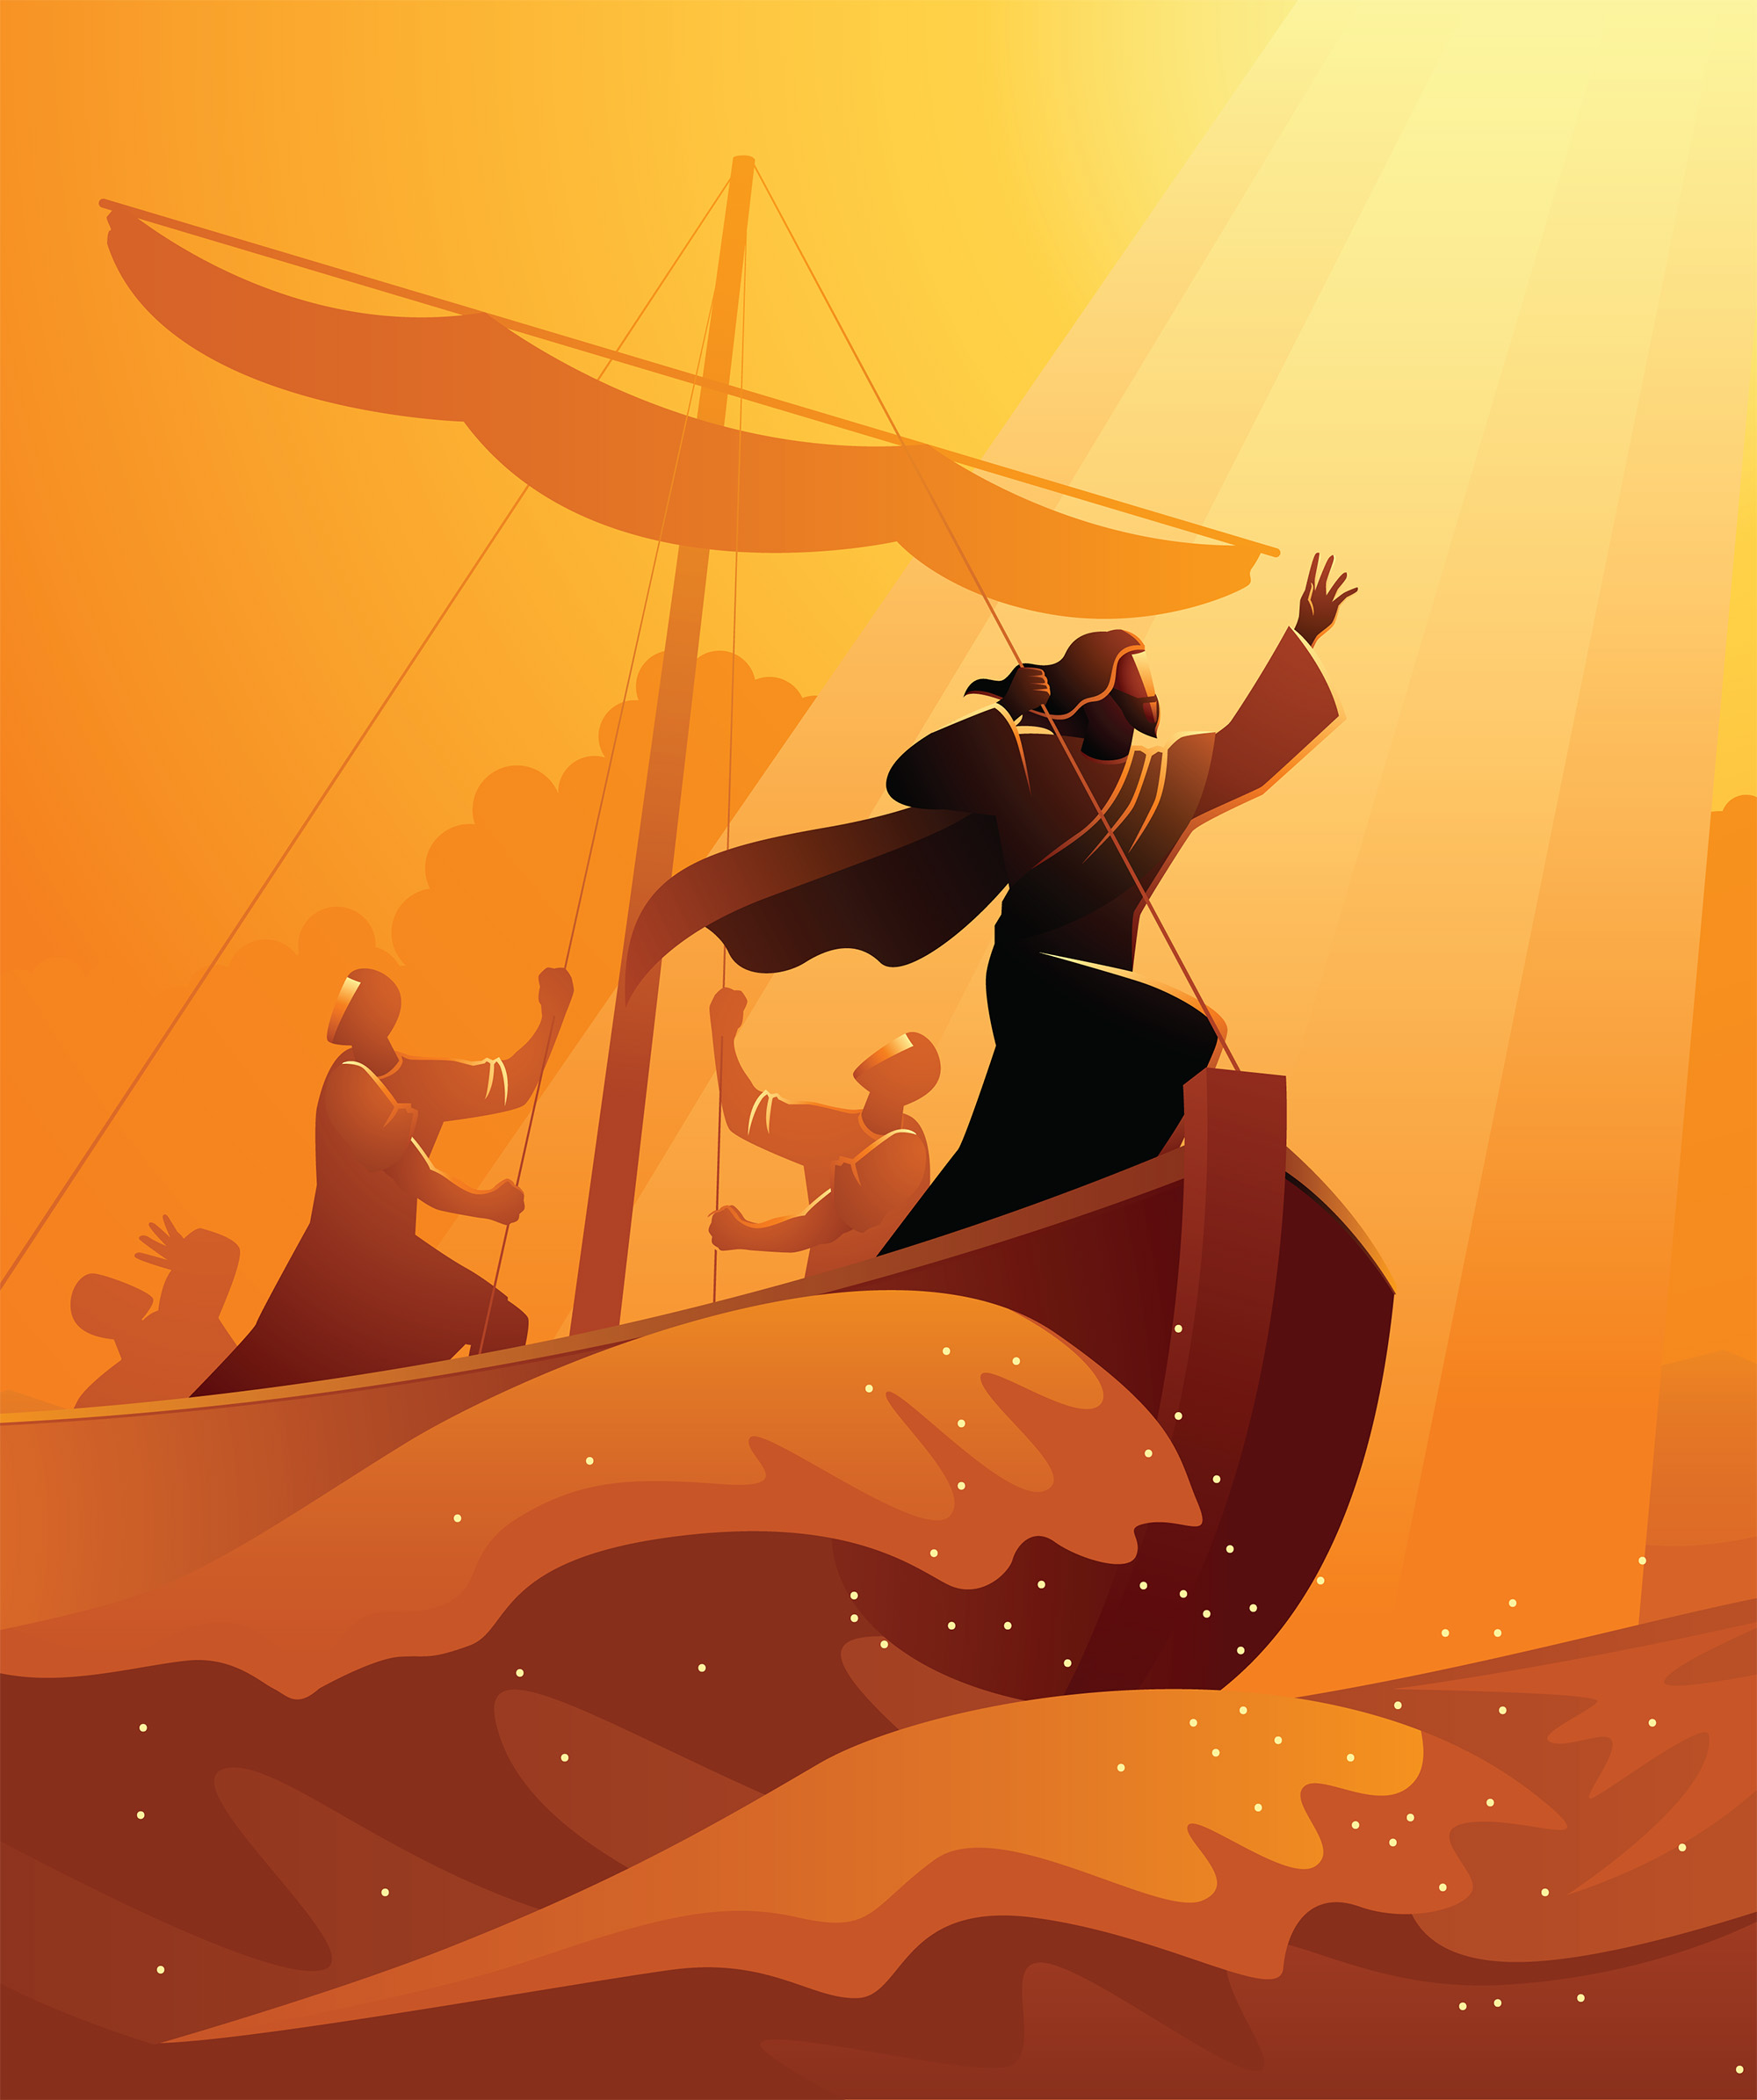

This Week

Theme: Being courageous
How this works
As a family, do some physical exercise 3 days a week (though even once is helpful!). If you can do it more often, then do other types of exercise too – walking, jogging, riding, skating, or swimming.
Each week of family.fit has a theme. The focus this week is how to develop courage. Each step below helps you explore the theme together.
Each session is an adventure made up of 7 steps.
There are 3 options for each step, giving 3 days of exercise programming.
7 Steps of family.fit
- Warm-up
- Talk
- Move
- Challenge
- Explore
- Pray
- Play

Remember anyone in the household can take the phone and lead a different step in the adventure.
Have fun together!

Step 1 | Warm-up

Start moving the whole body 5 min
Do the following whole body warm-ups.
Warm-up to music
DAY 1
Put on some up-tempo music and do the following (5 rounds):
20 running on the spot
5 squats
20 high knees running
5 to the floor - to the sky
See the Warm-up video.
Warm-up to music
DAY 2
2
Do the same as day 1.
Tidy up with a song
DAY 3

Put on a favorite up-tempo song. As the music plays, everyone must pick up things and put them away - toys, papers, cups and mess. Move quickly and enjoy the hard work for about 4 minutes.

Step 2 | Talk together

Rest and start a conversation 5 min
Sit or stand together and start a conversation. Here are some questions to get you started.
Discuss
DAY 1
What scares you?
How have you tried to be courageous when facing a fear?
Discuss
DAY 2
2
Tell of a time you helped someone else when they were afraid. Or when someone helped you.
What difference does it make to be courageous with someone else, rather than on your own?
Discuss
DAY 3

What do you need courage for today or this week?
Can you think of ways to face it together as a family and find the courage you need?

Step 3 | Move

Move and do sit-ups 5 min
Learn and practice sit-ups to help your core muscles.
Practice the sit-up
DAY 1
Watch Sit-up Video.
Practice this movement in pairs. Start slowly and carefully.
Sit-ups and squats
DAY 2
2
Work in pairs. One person does sit-ups then taps to the other person. Alternate between 5 sit-ups and 5 squats.
5 rounds.
Try other types of sit-ups
DAY 3

See easier Scaled sit-ups.
Practice them together.
Do the crunch
Do sit-ups with hands

Step 4 | Challenge

Move in a family challenge 10 min
Challenging each other helps give you energy.
Family challenge
DAY 1
Watch video Family Challenge.
Sit in a circle facing each other. Do 50 sit-ups as a family. One person starts to do sit-up repetitions. Tap out to the next person when you need a break.
After 50 sit-ups, run as a family to a marker and back. Run to pace of slowest runner. Then start sit-ups again. Do 3 rounds of 50.
Color relay
DAY 2
2
Choose a favorite color together. Each person must run and collect 5 pieces of clothing or objects of that color, one piece at a time and bring it back to the starting point. Race against the clock.
Family challenge
DAY 3

Repeat the activity from Day 1 but try to do 5 rounds.

Step 5 | Explore

Explore the Bible together 5 min
Explore the Life Question - “How can I develop courage?” Read the story from Mark 4 (next page).
Read and discuss together
DAY 1
Imagine yourself in the boat ... how do you think you would feel?
What do you think about Jesus?
What are you facing now that makes you feel the same way as the disciples?
Reread and discuss together
DAY 2
2
Act out the story and use anything nearby to help you.
When things get difficult, who do you turn to?
What do you think this story tells us about Jesus?
Reread the Bible verse
DAY 3

Write down a situation where you will need courage in the next few days. Scrunch up the paper and throw it as far as possible. As you do it, you might want to pray and ask God to be with you and give you courage.

A story about courage
The following is a story of Jesus from chapter 4 of the Book of Mark in the Bible. If you want to read the story look in a Bible or visit BibleGateway (or download the Bible App).
Optional video | Jesus calms the storm
When evening came, Jesus said to his disciples, “Let’s go over to the other side of the lake.” They left the crowd behind. And they took him along in a boat, just as he was. There were also other boats with him. A wild storm came up. Waves crashed over the boat. It was about to sink. Jesus was in the back, sleeping on a cushion. The disciples woke him up. They said, “Teacher! Don’t you care if we drown?”
He got up and ordered the wind to stop. He said to the waves, “Quiet! Be still!” Then the wind died down. And it was completely calm. He said to his disciples, “Why are you so afraid? Don’t you have any faith at all yet?” They were terrified. They asked each other, “Who is this? Even the wind and the waves obey him!”
(Mark 4:35-41 NIRV)

Step 6 | Pray

Pray and cool down 5 min
Take time to look outwards and pray for others.
Stretching prayers
DAY 1
Look at the video on stretching and complete some of the body stretches.
Pray for each other as you stretch.
Pray for friends or neighbors
DAY 2
2
Think of family friends or neighbors. Imagine what might make them afraid.
Pray for them. Then call or send a message to encourage them.
Health and nutrition
DAY 3

Look at a glass of clean water together. It is clear, and often free and plentiful. Think about all the things that fresh water gives us.
Find out why water is good for the body.
Fact: your body is mostly made up of water. You need to replace water that you lose every day.
How many big glasses of water do you need to drink each day?

Step 7 | Play together

Play games as a family 5 min
Play together in active challenges (involving agility, speed and cardio) and quiet games.
Relay
DAY 1
Mark the length of the relay. Each person must do a lap of each movement and tap the next in line. Examples: Run, hop, side steps, lunges, run backwards)
Time the family on stopwatch. See Relay video.
Play a game
DAY 2
2
Play an active game (or board game) familiar to the family. Have fun!
Ninja course
DAY 3

Set up a new course to follow. Use the space you have inside or outside (e.g. run to the tree/chair, leap over the path/rug, etc.) Be creative!
Take turns to get through the Ninja course as quickly as possible. Use a stopwatch to time each person.
Watch Ninja Video.

Terminology
- A warm-up is a simple action that gets muscles warm, breathing deeper, and blood pumping. Play fun, up-tempo music for your warm-up activities. Do a range of movements for 3-5 minutes.
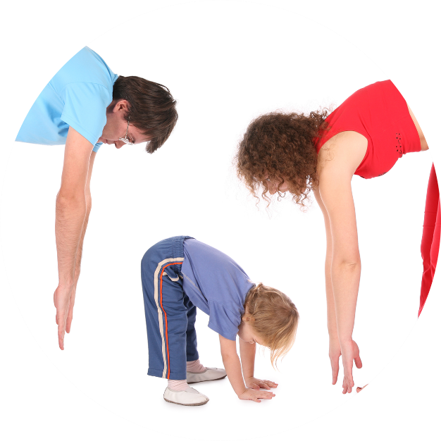
- Workout movements can be seen on the videos so you can learn the new exercise and practice it well. Starting slowly with a focus on technique will enable you to go faster and stronger later.
- Stretches are less likely to cause injury when done AFTER warm-ups. Use a slower piece of music to do stretches. Stretch gently – and hold for 5 seconds.
- Rest and recover after energetic movement. Conversation is great here.
- Tap out is a way to pass the exercise on to the next person. You can choose different ways to “tap out” e.g. hand clap, whistle, finger guns, wink etc. You make it up!

Video links
Find all the videos for family.fit at https://family.fit/ or at the family.fit YouTube® channel

family.fit promo video
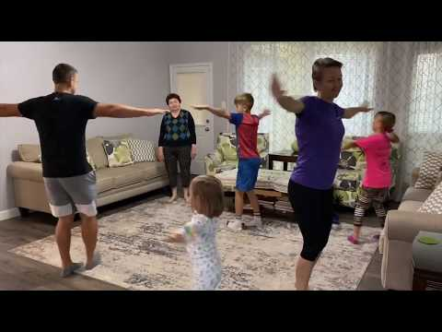
family.fit video
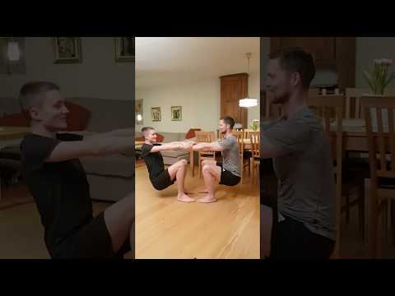
family.fit mobile video

Please Stay Connected
We hope you have enjoyed this booklet of family.fit. It has been put together by volunteers from around the world. You will find all new family.fit sessions on the website https://family.fit
The website has the latest information, ways you can feedback your thoughts and is the place to stay connected with family.fit!
If you enjoyed this, please share with your friends and others you know who might like to participate.
This resource is given freely and meant to be freely given to others at no cost.
If you translate this into your language, please share it back on the website or email it to info@family.fit so it can be shared with others.
Thank you.
The family.fit team

- ourage.

Web: www.family.fit
Email: info@family.fit
Web: www.family.fit
Email: info@family.fit

