family.fitness.faith.fun

What does hope look like?

A vaccine for isolated days!
Help your family be fit and healthy, stay connected, and grow in character.
3
WEEK

www.family.fit
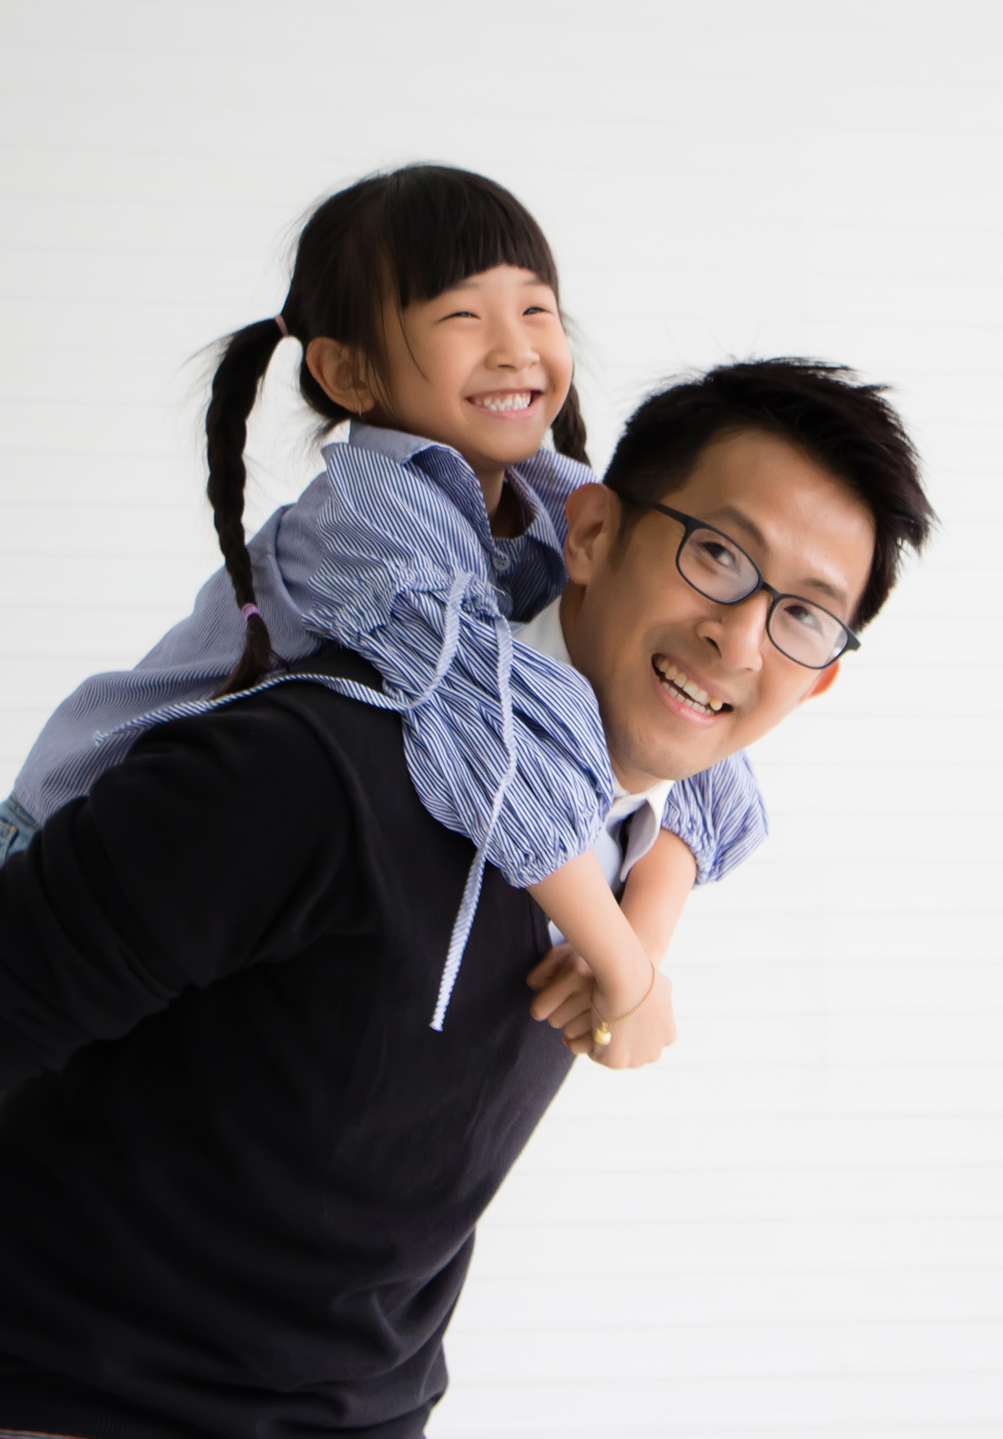

How to make fitness
an important part of your family’s life:

Make it fun
- Be active together
Do exercise a few times a week.
Find a time that will work for everyone.

- Play games
- Involve everyone in the household
- Go inside or outside
- Be creative and improvise with what you have

Challenge each other
- Allow different levels of challenge according to ability, size and age
Set personal
goals.
Compare improvements with your personal best.
- Respect each other
- Listen actively
- Share family.fit! It’s free.
- Don’t do exercises that cause pain or make any existing pain worse.
- Don’t exercise if you are sick. Wash hands before and after family.fit.
IMPORTANT AGREEMENT BEFORE USING THIS RESOURCE
By using this resource you agree to our Terms and Conditions https:/family.fit/terms-and-conditions/ as detailed in full on our website. These govern your use of this resource by you and all those exercising with you. Please ensure that you and all those exercising with you accept these terms and conditions in full. If you disagree with these terms and conditions or any part of these terms and conditions, you must not use this resource.

This Week

Theme: Lasting hope
How this works
As a family, do some physical exercise 3 days a week (though even once is helpful!). If you can do it more often, then do other types of exercise too – walking, jogging, riding, skating, or swimming.
Each week of family.fit has a theme. The focus this week is having hope. Each step below helps you explore the theme together.
Each session is an adventure made up of 7 steps.
There are 3 options for each step, giving 3 days of exercise programming.
7 Steps of family.fit
- Warm-up
- Talk
- Move
- Challenge
- Explore
- Pray
- Play

Remember anyone in the household can take the phone and lead a different step in the adventure.
Have fun together!

Step 1 | Warm-up

Start moving the whole body 5 min
Do the following whole body warm-ups.
Junkyard dog
DAY 1
One person sits on the floor with legs out to the front and arms out to the side. Each person jumps over the arm, the legs and the second arm. Everybody jumps 2 rounds and changes places so everybody gets to jump.
See the junkyard dog video.
Follow the leader
DAY 2
2
Go for a short jog around the house or yard while everyone follows a chosen leader. Try to go to every room or space. The leader can change movements, eg. side steps or high knees. Swap leaders.
Junkyard dog video
DAY 3

Repeat day 1 activity. Do 3 rounds each.
See the junkyard dog video.

Step 2 | Talk together

Rest and start a conversation 5 min
Sit or stand together and start a conversation. Here are some questions to get you started.
Discuss
DAY 1
Can you remember a time when something you hoped for did not happen?
What were your feelings?
What are you hoping for right now?
Discuss
DAY 2
2
What have been some memorable surprises in your life?
What made them so special and memorable?
Discuss
DAY 3

If you hope for something and it doesn’t happen, you will be disappointed. So why should we have hope?
How can you have hope when what you want is outside your control?

Step 3 | Move

Move and do lunges 5 min
Learn and practice lunges to help your core muscles.
Practice the lunge
DAY 1
Watch Lunge video.
Practice this movement in pairs. Start slowly and carefully.
Lunge relay
DAY 2
2
One person does a lunge walk around a chair and back, then taps another person to do the lunge walk.
Everyone does ski-jumps together.
2 rounds. See Lunge relay video.
Partner squat
DAY 3

Stand facing a partner. Hold each other’s wrists. Squat at the same time.
3 rounds of 10.
See video.

Step 4 | Challenge

Move in a family challenge 10 min
Challenging each other helps give you energy.
Family challenge
DAY 1
Watch video Family Challenge.
Write labels for the 6 movements below (one per card) and place in a circle. One person spins a bottle and does the movement it points to. Tap to the next family member.
Challenge: 100 movements as a family.
5 lunges, 5 squats, 5 jumping jacks, 10 ski-jumps, 5 sit-ups, 10 high knees
Tabata
DAY 2
2
Listen to the Tabata music. Everyone does sit-ups for 20 seconds then rests for 10 seconds. Everyone squats for 20 seconds then rests for 10 seconds.
8 rounds. See Tabata Video.
Family challenge
DAY 3

Repeat the activity from Day 1. Challenge: complete 150 movements.

Step 5 | Explore

Explore the Bible together 5 min
Explore the Life Question - “What does hope look like? Read the words of Jesus from John 3 (next page).
Read and discuss together
DAY 1
Hope died.
During His time on earth, crowds of people gathered to see and hear Jesus. Why were people so interested in Jesus? What were they hoping for?
Can you imagine some of their feelings on the day He died?
Reread and discuss together
DAY 2
2
Hope alive.
God had a much bigger plan when Jesus died on the cross. How does God raising Jesus from the dead give you hope?
Take turns to read or recite the words in bold from the reading (verse 16), adding your own actions as a reminder of the hope that God has given us in Jesus.
Reread the Bible verse
DAY 3

Hope eternal.
What does hope mean or look like for you as a family?
‘Eternal’ is not a widely used word. How would you explain it?
In light of the circumstances we face today, how might the promise of eternal life shape your life?

Words of hope
The following is what Jesus said. It is found in chapter 3 of the Book of John in the Bible. If you want to read the story look in a Bible or visit BibleGateway (or download the Bible App).
And as Moses lifted up the serpent in the wilderness*, so must the Son of Man be lifted up, that whoever believes in him may have eternal life. For God so loved the world, that he gave his only Son, that whoever believes in him should not perish but have eternal life. For God did not send his Son into the world to condemn the world, but in order that the world might be saved through him.
(John 3:14-17 NIV)
*You can find this story in
Numbers 21:4-9 to read later.

Step 6 | Pray

Pray and cool down 5 min
Take time to look outwards and pray for others.
Fold a cross
DAY 1
Try folding and making your own paper cross. As each person in the household tears their paper into a cross shape silently, remember and thank Jesus in your own way.
See paper folding video.
Prayer of hope
DAY 2
2
Write a prayer with each line beginning with a letter of the word ‘HOPE’. You can write it on your cross. Read them to each other as you pray.
Pray and stretch
DAY 3

Jesus offers hope to those who believe in Him. Many still don’t know Him or have that hope. Pray for yourself, or some of your family and friends to find hope in Jesus.

Step 7 | Play together

Play games as a family 5 min
Play together in active challenges. Have fun!
Tag
DAY 1
One player is IN. This person runs around an area to try and tag another person. Once tagged, the new person is IN and tags another. If a player is doing squats they cannot be tagged (3 squat maximum). Change taggers regularly.
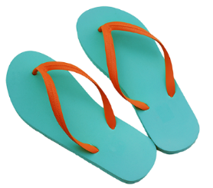
Flip-flop relay
DAY 2
2
See flip flop video.
Work in pairs. One will be the walker, the other will move the flip-flops. The walker walks slowly across the room while the other person moves the two flip-flops so that the walker always steps on a flip-flop. Swap places.
3 rounds.
In the last round the walker can have their eyes closed. What happens?
Trust fall
DAY 3

The smallest family member falls backwards and is caught by the others. Swap places. See Trust Fall video.

Terminology
- A warm-up is a simple action that gets muscles warm, breathing deeper, and blood pumping. Play fun, up-tempo music for your warm-up activities. Do a range of movements for 3-5 minutes.
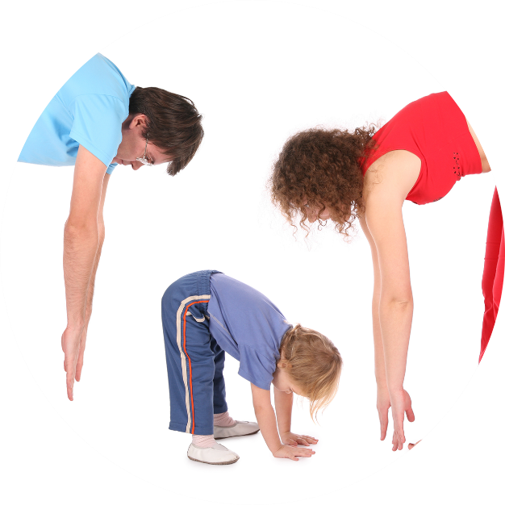
- Workout movements can be seen on the videos so you can learn the new exercise and practice it well. Starting slowly with a focus on technique will enable you to go faster and stronger later.
- Stretches are less likely to cause injury when done AFTER warm-ups. Use a slower piece of music to do stretches. Stretch gently – and hold for 5 seconds.
- Rest and recover after energetic movement. Conversation is great here.
- Tap out is a way to pass the exercise on to the next person. You can choose different ways to “tap out” e.g. hand clap, whistle, finger guns, wink etc. You make it up!

Video links
Find all the videos for family.fit at https://family.fit/ or at the family.fit YouTube® channel

family.fit promo video
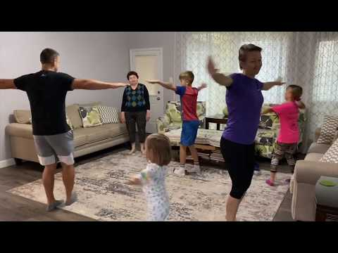
family.fit video
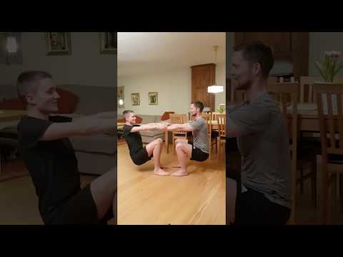
family.fit mobile video

Please Stay Connected
We hope you have enjoyed this booklet of family.fit. It has been put together by volunteers from around the world. You will find all new family.fit sessions on the website https://family.fit
The website has the latest information, ways you can feedback your thoughts and is the place to stay connected with family.fit!
If you enjoyed this, please share with your friends and others you know who might like to participate.
This resource is given freely and meant to be freely given to others at no cost.
If you translate this into your language, please share it back on the website or email it to info@family.fit so it can be shared with others.
Thank you.
The family.fit team

- ourage.

Web: www.family.fit
Email: info@family.fit
Web: www.family.fit
Email: info@family.fit

