family.fitness.faith.fun

How do we find peace?

A vaccine for isolated days!
Help your family be fit and healthy, stay connected, and grow in character.
4
WEEK

www.family.fit

How to make fitness
an important part of your family’s life:

Make it fun
- Be active together
Do exercise a few times a week.
Find a time that will work for everyone.

- Play games
- Involve everyone in the household
- Go inside or outside
- Be creative and improvise with what you have

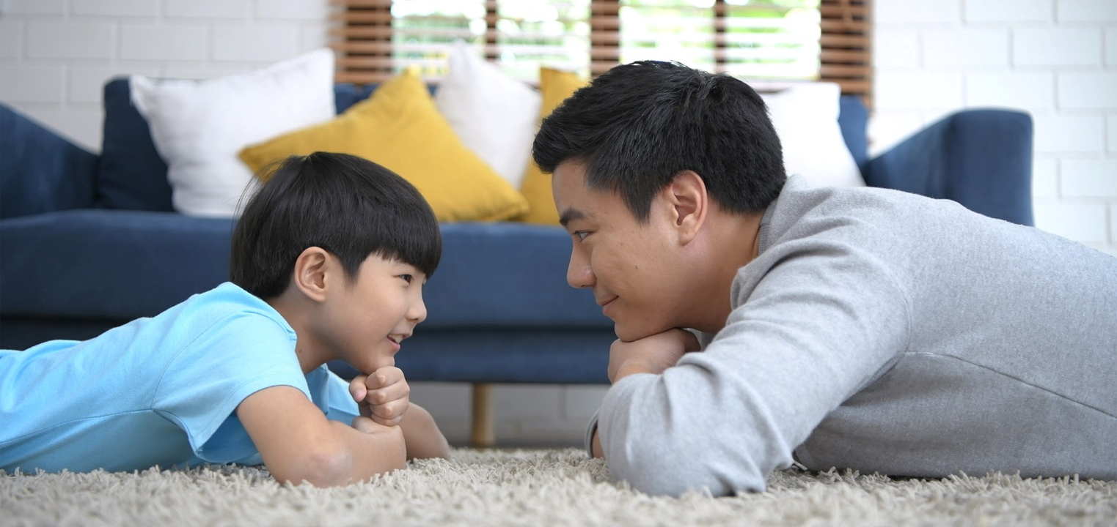

Challenge each other
- Allow different levels of challenge according to ability, size and age
Set personal
goals.
Compare improvements with your personal best.
- Respect each other
- Listen actively
- Share family.fit! It’s free.
- Don’t do exercises that cause pain or make any existing pain worse.
- Don’t exercise if you are sick. Wash hands before and after family.fit.
IMPORTANT AGREEMENT BEFORE USING THIS RESOURCE
By using this resource you agree to our Terms and Conditions https:/family.fit/terms-and-conditions/ as detailed in full on our website. These govern your use of this resource by you and all those exercising with you. Please ensure that you and all those exercising with you accept these terms and conditions in full. If you disagree with these terms and conditions or any part of these terms and conditions, you must not use this resource.
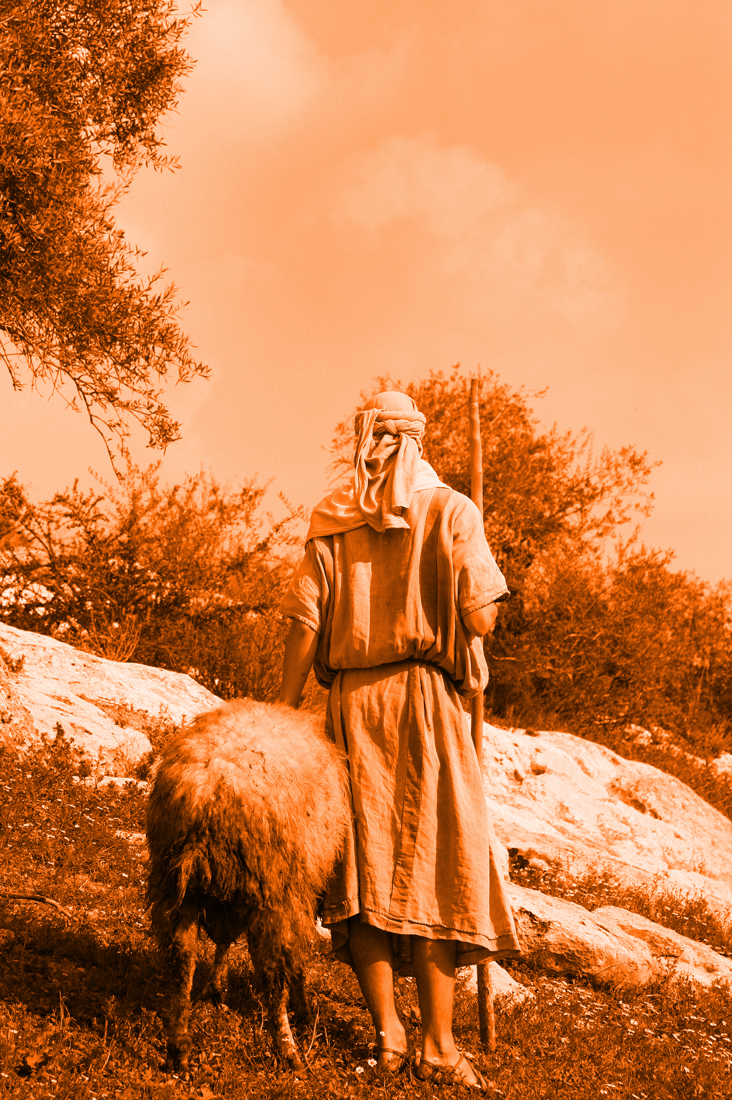

This Week

Theme: Finding peace
How this works
As a family, do some physical exercise 3 days a week (though even once is helpful!). If you can do it more often, then do other types of exercise too – walking, jogging, riding, skating, or swimming.
Each week of family.fit has a theme. The focus this week is finding peace. Each step below helps you explore the theme together.
Each session is an adventure made up of 7 steps.
There are 3 options for each step, giving 3 days of exercise programming.
7 Steps of family.fit
- Warm-up
- Talk
- Move
- Challenge
- Explore
- Pray
- Play

Remember anyone in the household can take the phone and lead a different step in the adventure.
Have fun together!

Step 1 | Warm-up

Start moving the whole body 5 min
Do the following whole body warm-ups.
Wheelbarrow and inchworm
DAY 1
Wheelbarrow: Work with a partner. Walk 10 meters then swap places.
Inchworm: Bend at the waist and place your hands on the floor. Walk your hands out until you're in a plank position with a flat back. Then walk your feet as close to your hands as you can. Repeat for 10 meters. 3 rounds. Watch video
Arm circles and body shapes
DAY 2
2
Arm circles: Stand in a circle and together complete 15 of each arm movement. Small circles forward, small circles backward, big circles forward, big circles backward.
Body shapes: Lie face down, arms overhead and palms facing each other. Move your arms into each formation.
3 rounds. Watch video
Wheelbarrow and inchworm
DAY 3

Repeat day 1 activity. Do 3 rounds each.

Step 2 | Talk together

Rest and start a conversation 5 min
Sit or stand together and start a conversation. Here are some questions to get you started.
Discuss
DAY 1
What comes into your mind when you have nothing else to think about?
What kinds of worries do you have? Talk about these together.
How do you deal with these worries?
Discuss
DAY 2
2
Think of some examples of when you helped someone who was anxious or worried. Or when someone helped you.
Do you have a particular place that you find restful or peaceful? What makes it special for you?
Discuss
DAY 3

How do you deal with worry as a family?
Are there others you know who are facing worries? Can you think of ways that together as a family you could support them?

Step 3 | Move

Move and do push-ups 5 min
Learn and practice push-ups to help your core, shoulder and arm muscles.
Practice the push-up
DAY 1
Practice this movement in pairs. Start slowly and carefully.
Easier: Knees on the ground or hands on a wall.
Harder: Feet on the ground.
Watch video
Push-ups and sit-ups
DAY 2
2
Work in pairs. One person does 5 push-ups and 5 sit-ups then taps to the other person. 5 rounds.
Harder push-ups
DAY 3

See other versions of the push-up.
Partner high five.
Feet on chair.
Watch video

Step 4 | Challenge

Move in a family challenge 10 min
Challenging each other helps give you energy.
Family challenge
DAY 1
You will need 10 items (eg. toys, socks, shoes). Place them in the middle of your circle. On GO, the first person does 5 push-ups and then removes one of the items. Tap out to the next person. The goal is to empty the pile, then 'refill' the pile. 5 push-ups equal 1 item in the pile. Watch Video
Push-up ball challenge
DAY 2
2
Line up in the push-up position. Place a ball at the end of the row. Person 1 does a push-up and then passes the ball to the next person. Continue along the line for 1 minute and see how many times you can get the ball down and back. 3 rounds.
Rest for 1 minute between rounds. Watch Video
Family challenge
DAY 3

Repeat the activity from Day 1. Challenge: beat your time from day 1 or increase rounds.

Step 5 | Explore

Explore the Bible together 5 min
Explore the Life Question - “How do we find peace? Read the words of an ancient song - Psalm 23, written by King David.
Read and discuss together
DAY 1
As you read this Psalm, what images does it create in your mind?
How does it make you feel?
What do you think it means for the Lord to be your shepherd?
Reread and discuss together
DAY 2
2
Choose a line from the Psalm. In pairs, use your bodies to strike a pose and let the others guess which line it is. Take turns until you have done all the lines.
Which image do you like best? Why? Draw a picture of that image adding the words underneath.
Retell the Bible verse
DAY 3

Psalm 23 is a word picture about God being with us, written by King David. This is the same David who was famous for fighting the giant Goliath when he was young. He was a shepherd before he was king and likely wrote this then. Work together to write something similar about God that connects with your life as a family.

Words of peace
The following is what King David wrote. It is the 23rd Psalm in the Book of Psalms in the Bible. If you want to read these song lyrics look in a Bible or visit BibleGateway (or download the Bible App).
The Lord is my shepherd, I lack nothing.
He makes me lie down in green pastures,
he leads me beside quiet waters,
he refreshes my soul.
He guides me along the right paths
for his name’s sake.
Even though I walk
through the darkest valley,
I will fear no evil,
for you are with me;
your rod and your staff,
they comfort me.
You prepare a table before me
in the presence of my enemies.
You anoint my head with oil;
my cup overflows.
Surely your goodness and love
will follow me all the days of my life,
and I will dwell in the house of the Lord forever.
Psalm 23 (NIV)

Step 6 | Pray

Pray and cool down 5 min
Take time to look outwards and pray for others.
Fist to palm prayers
DAY 1
Everyone sits in a relaxed position. Squeeze hands into fists as tight as you can, breathing in. As you squeeze, think about all the worries you have, squeezing harder all the time. Then really slowly, release and unfold your hands, breathing out gently. As you do, picture God as your Shepherd. Give Him all your worries.
Repeat if there are more things you are anxious or worried about.
Pray for others
DAY 2
2
Think of family, friends or neighbors. What might they be anxious about? Pray for them.
Write a card, send a message, or give them a call to let them know you are thinking of them.
Pray and stretch
DAY 3

Pray as you stretch your bodies or repeat fist to palm prayers.
See stretching video

Step 7 | Play together

Play games as a family 5 min
Play together in active challenges. Have fun!
Trust fall
DAY 1
Do the trust fall in two new ways.
1. One person stands between two others and rocks backwards and forwards with eyes closed. What did it feel like being caught by the family?
2. Stand on a chair, close eyes and fall backwards into the hands of the family.
Watch video
The great paper competition
DAY 2
2
Everyone gets a piece of paper. Write what takes away your peace on it. Then use the paper for 3 different competitions. Watch video
1. Make a paper airplane and fly it the furthest. Give points to each person.
2. Screw up the paper plane into a ball. Each person throws all the balls into a bucket 5 meters away. See who can get the highest total.
3. Try to juggle the most paper balls. Start with one, then two and so on. Who has the highest overall score?
Play a quiet board game
DAY 3

Play a quiet board game that brings peace to the family.

Terminology
- A warm-up is a simple action that gets muscles warm, breathing deeper, and blood pumping. Play fun, up-tempo music for your warm-up activities. Do a range of movements for 3-5 minutes.
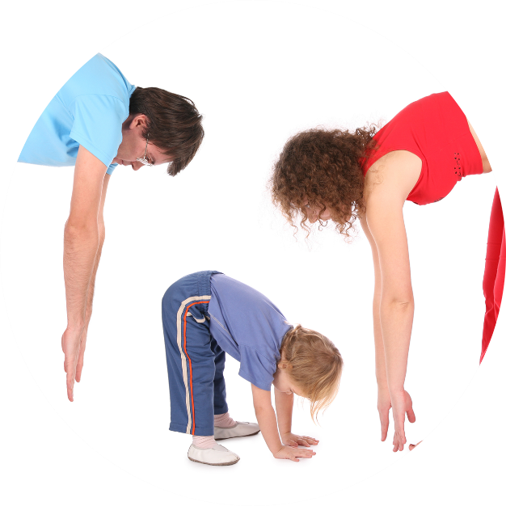
- Workout movements can be seen on the videos so you can learn the new exercise and practice it well. Starting slowly with a focus on technique will enable you to go faster and stronger later.
- Stretches are less likely to cause injury when done AFTER warm-ups. Use a slower piece of music to do stretches. Stretch gently – and hold for 5 seconds.
- Rest and recover after energetic movement. Conversation is great here.
- Tap out is a way to pass the exercise on to the next person. You can choose different ways to “tap out” e.g. hand clap, whistle, finger guns, wink etc. You make it up!

Video links
Find all the videos for family.fit at https://family.fit/ or at the family.fit YouTube® channel

family.fit promo video
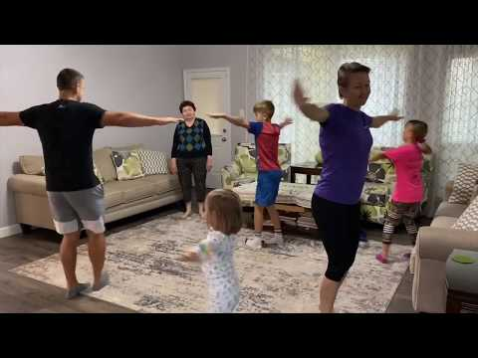
family.fit video
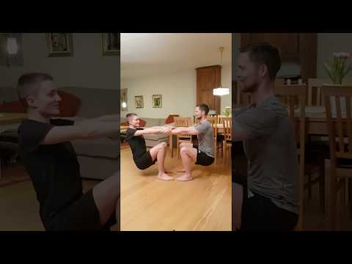
family.fit mobile video

Please Stay Connected
We hope you have enjoyed this booklet of family.fit. It has been put together by volunteers from around the world. You will find all new family.fit sessions on the website https://family.fit
The website has the latest information, ways you can feedback your thoughts and is the place to stay connected with family.fit!
If you enjoyed this, please share with your friends and others you know who might like to participate.
This resource is given freely and meant to be freely given to others at no cost.
If you translate this into your language, please share it back on the website or email it to info@family.fit so it can be shared with others.
Thank you.
The family.fit team

- ourage.

Web: www.family.fit
Email: info@family.fit
Web: www.family.fit
Email: info@family.fit

