family.fitness.faith.fun

Am I thankful?

A vaccine for isolated days!
Help your family be fit and healthy, stay connected, and grow in character.
5
WEEK

www.family.fit

How to make fitness
an important part of your family’s life:

Make it fun
- Be active together
Do exercise a few times a week.
Find a time that will work for everyone.

- Play games
- Involve everyone in the household
- Go inside or outside
- Be creative and improvise with what you have

Challenge each other
- Allow different levels of challenge according to ability, size and age
Set personal
goals.
Compare improvements with your personal best.
- Respect each other
- Listen actively
- Share family.fit! It’s free.
- Don’t do exercises that cause pain or make any existing pain worse.
- Don’t exercise if you are sick. Wash hands before and after family.fit.
IMPORTANT AGREEMENT BEFORE USING THIS RESOURCE
By using this resource you agree to our Terms and Conditions https:/family.fit/terms-and-conditions/ as detailed in full on our website. These govern your use of this resource by you and all those exercising with you. Please ensure that you and all those exercising with you accept these terms and conditions in full. If you disagree with these terms and conditions or any part of these terms and conditions, you must not use this resource.
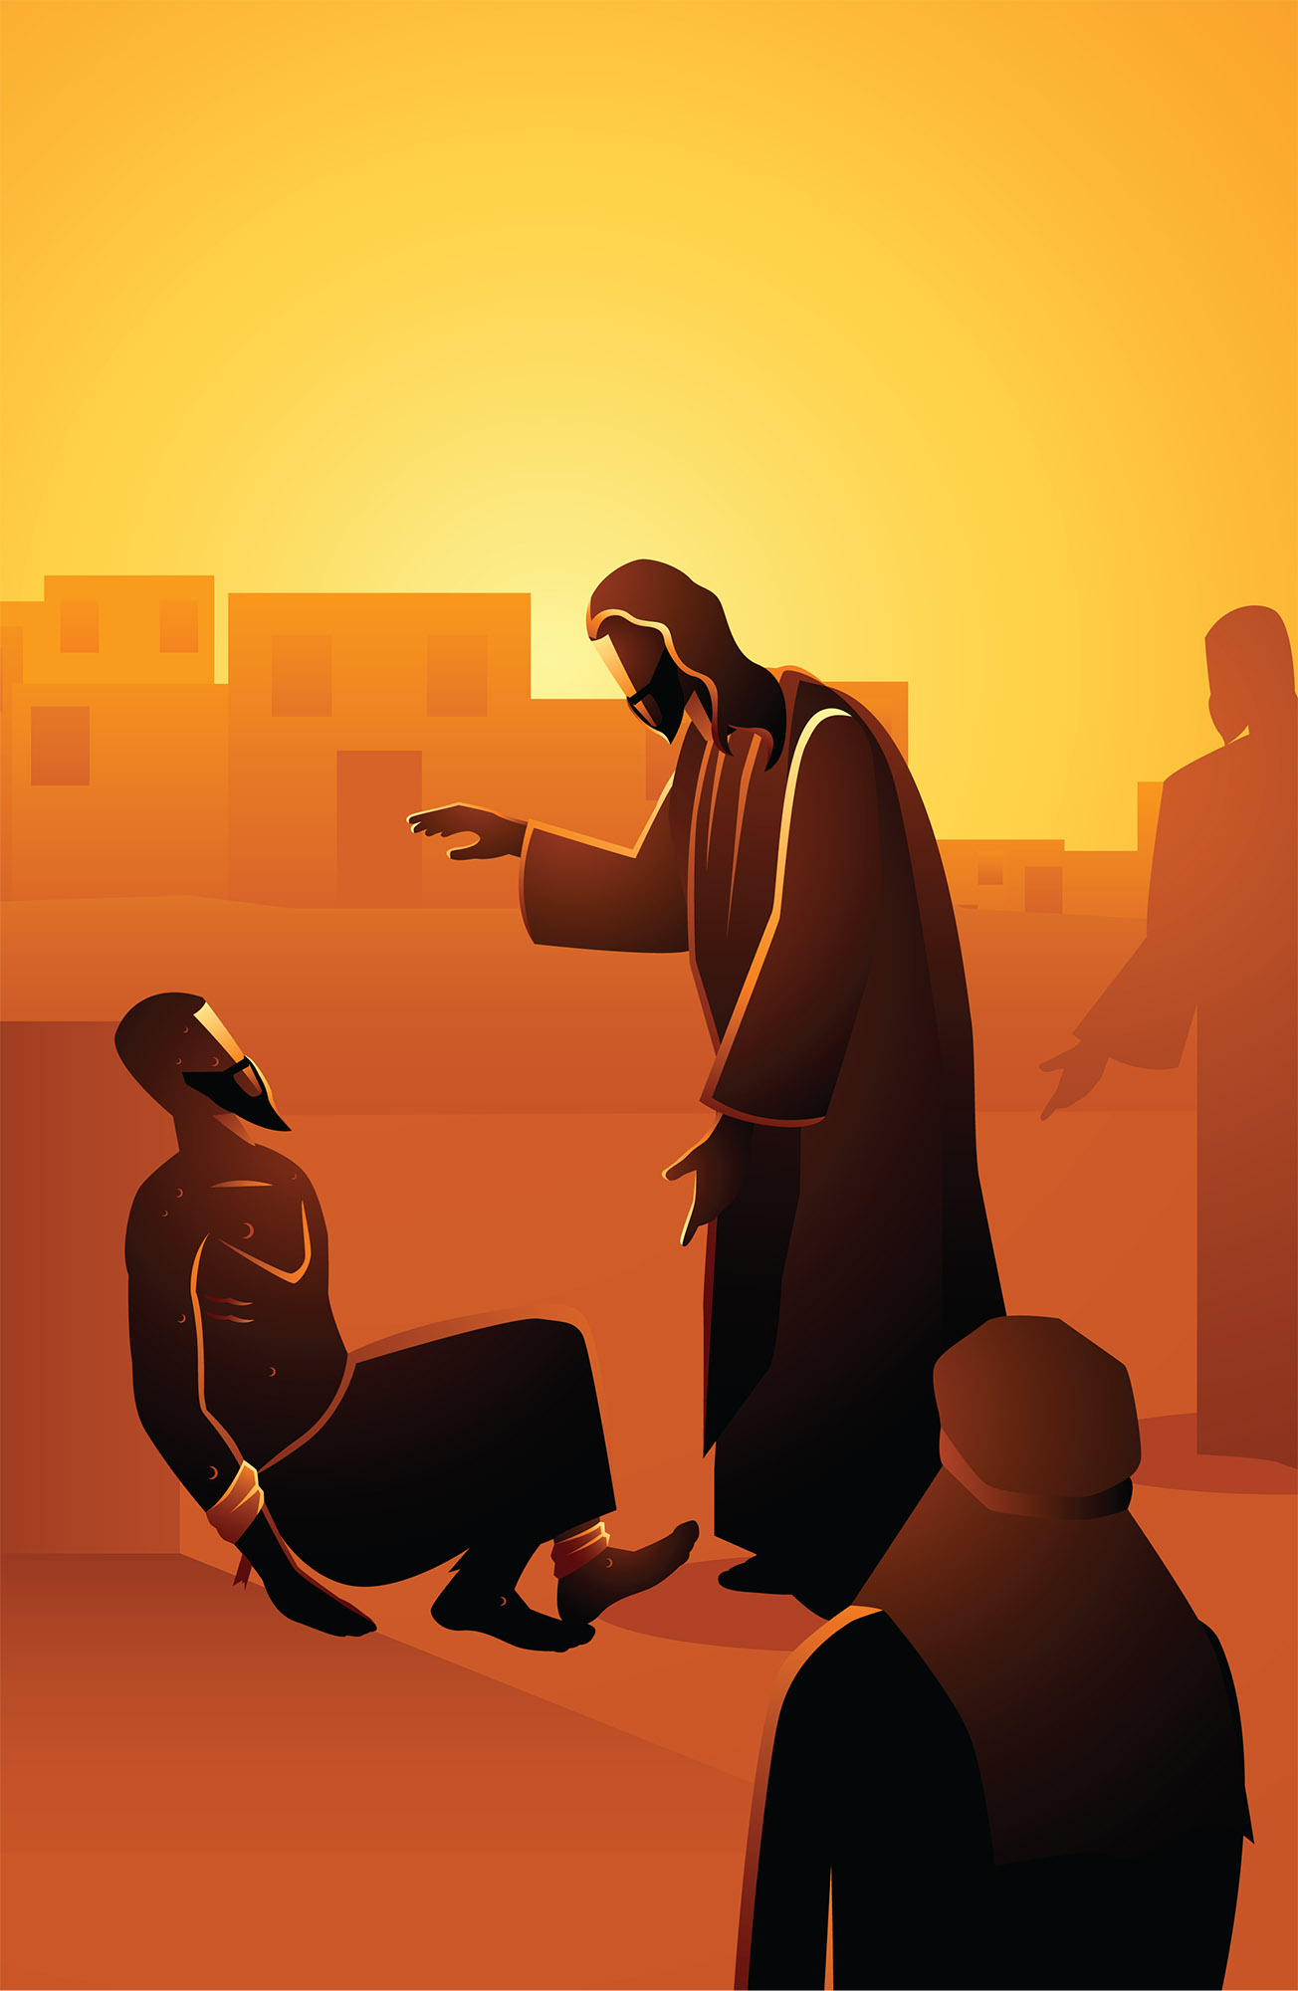

This Week

Theme: Being thankful
How this works
As a family, do some physical exercise 3 days a week (though even once is helpful!). If you can do it more often, then do other types of exercise too – walking, jogging, riding, skating, or swimming.
Each week of family.fit has a theme. The focus this week is being thankful. Each step below helps you explore the theme together.
Each session is an adventure made up of 7 steps.
There are 3 options for each step, giving 3 days of exercise programming.
7 Steps of family.fit
- Warm-up
- Talk
- Move
- Challenge
- Explore
- Pray
- Play

Remember anyone in the household can take the phone and lead a different step in the adventure.
Have fun together!

Step 1 | Warm-up

Start moving the whole body 5 min
Do the following whole body warm-ups.
Get moving
DAY 1
Follow the movements of the video (walking on the spot, leg stretches, side stretches, shoulder stretches etc).
Watch warm-up video 1
Move to music
DAY 2
2
Do six exercises to up-tempo music:
10 jumps left and right
10 jumps on the spot
10 side stretches
10 leg stretches
10 side stretch (other form)
10 shoulders and neck
Watch warm-up video 2
Get moving
DAY 3

Repeat day 1 activity.

Step 2 | Talk together

Rest and start a conversation 5 min
Sit or stand together and start a short conversation. Here are some questions to get you started.
Discuss
DAY 1
What are you thankful for today?
Have you said thank you to anyone today ... for what?
If not, plan who you could thank and when.
Discuss
DAY 2
2
As a family, think of something to be thankful for, for each letter of the alphabet.
Can you do it twice?
Discuss
DAY 3

Are there times when you’ve forgotten to say thank you?
Have there been times when someone didn’t thank you when you thought they should?
How did you feel?

Step 3 | Move

Move and do planks 5 min
Learn and practice the plank to help your core, shoulder and arm muscles.
Practice the plank
DAY 1
Watch a plank and practice this movement in pairs. Start slowly and carefully.
Watch video
Plank tabata
DAY 2
2
Place an object in front of you and get in the plank position. Reach with your right hand and touch the object and then again with your left. Repeat this as many times as you can in 20 seconds and then rest for 10 seconds. Repeat this for 8 rounds. Count the total number of times you touch the object.
Watch video
Harder Planks
DAY 3

Plank Jacks - while in the plank position, jump your feet apart and then back together.
Watch video

Step 4 | Challenge

Move in a family challenge 10 min
Challenging each other helps give you energy.
Family challenge
DAY 1
Form a circle by lying face down on the floor with heads towards the middle. While everyone does a plank, each person takes turns to say the name of an animal. After completing 15 names as a family, rest for 20 seconds.
For the next 4 rounds, complete other categories: colors, fruit, famous people, and cities. Watch video
One minute challenge
DAY 2
2
Face a partner in the plank position. On GO, give each other ‘high fives’ with the right hand and then with the left hand until you have given each other 20 ‘high fives’. Rest for 60 seconds. 6 rounds.
Watch video
Plank and jumping jack relay
DAY 3

One person does a plank while the others do 10 jumping jacks. Tap out to swap. Take a 20 second rest and start again. 6 rounds. Watch video

Step 5 | Explore

Explore the Bible together 5 min
Explore the Life Question – “Am I thankful?” by reading the true story from Luke 17 (next page) of how Jesus healed some men and taught us about being thankful at the same time.
Read and discuss together
DAY 1
The men in the story were sick and forced to live outside their village.
What does this story tell us about Jesus?
Describe your feelings if you were one of the men Jesus healed.
Reread and discuss together
DAY 2
2
Take turns to act out the part of the healed man, throwing yourself at the feet of Jesus (a family member). How would you say ‘thank you’?
Why didn’t the other 9 come back?
Reread and discuss together
DAY 3

Are there any people groups where you live who are treated as outcasts?
How might Jesus respond to them?
How have you been shown kindness as a family? Could you do anything as a family to show kindness to this group?

A story about being thankful
The following is a story of Jesus from chapter 17 of the Book of Luke in the Bible. If you want to read the story look in a Bible or visit BibleGateway (or download the Bible App).
Jesus was on his way to Jerusalem. He traveled along the border between Samaria and Galilee. As he was going into a village, ten men met him. They had a skin disease. They were standing close by. And they called out in a loud voice, “Jesus! Master! Have pity on us!”
Jesus saw them and said, “Go. Show yourselves to the priests.” While they were on the way, they were healed.
When one of them saw that he was healed, he came back. He praised God in a loud voice. He threw himself at Jesus’ feet and thanked him. The man was a Samaritan.
Jesus asked, “Weren’t all ten healed? Where are the other nine? Didn’t anyone else return and give praise to God except this outsider?” Then Jesus said to him, “Get up and go. Your faith has healed you.”
Luke 17:11-19 (NIRV)

Step 6 | Pray

Pray and cool down 5 min
Take time to look outwards and pray for others.
Thankful moment
DAY 1
Be still and individually reflect on what you are thankful for.
Share one thing about each person in your family you are thankful for.
Thank God together for some of these things.
Pray for others
DAY 2
2
Think of some people you know who are sick or rejected. Draw and name some body outlines on paper for each, and pray for them.
Display on a wall as a reminder to pray. Thank God that He hears our prayers.
Pray and run
DAY 3

Set a timer for 1 minute, then everyone run around the house to grab items you are thankful for and bring them back.
Briefly explain what (or who) you are thankful for and take time to turn that thanks into prayer.

Step 7 | Play together

Play games as a family 5 min
Play together in active challenges. Have fun!
Paper ball circle
DAY 1
Family members each write what they are thankful for on the same sheet of paper. Screw up the paper into a ball and stand in a circle. Throw the paper ball to another person while giving them an exercise to do (lunges, squats, jogging in place, etc). Everyone then copies for 10 reps. Watch video
Don’t get caught
DAY 2
2
One person is ‘captain’. They turn their back to the rest of the family. The other family members have to do an exercise while the captain is not looking (high knees, skipping in place, jumping jacks, etc.) When the captain turns around everyone must freeze. If someone is caught moving, they become the new captain. Watch video
Board game
DAY 3

Play a quiet board game for fun.

Terminology
- A warm-up is a simple action that gets muscles warm, breathing deeper, and blood pumping. Play fun, up-tempo music for your warm-up activities. Do a range of movements for 3-5 minutes.
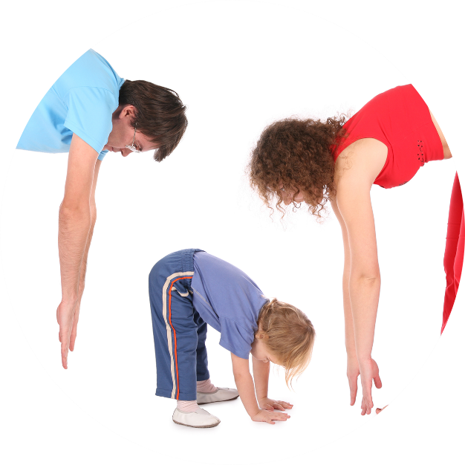
- Workout movements can be seen on the videos so you can learn the new exercise and practice it well. Starting slowly with a focus on technique will enable you to go faster and stronger later.
- Stretches are less likely to cause injury when done AFTER warm-ups. Use a slower piece of music to do stretches. Stretch gently – and hold for 5 seconds.
- Rest and recover after energetic movement. Conversation is great here.
- Tap out is a way to pass the exercise on to the next person. You can choose different ways to “tap out” e.g. hand clap, whistle, finger guns, wink etc. You make it up!

Video links
Find all the videos for family.fit at https://family.fit/ or at the family.fit YouTube® channel

family.fit promo video
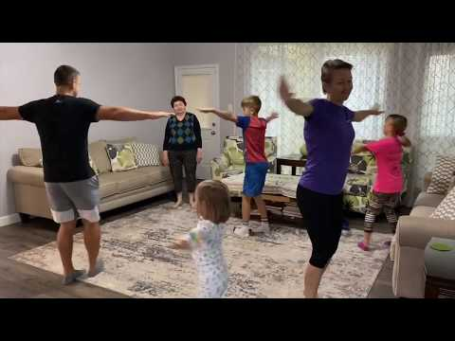
family.fit video
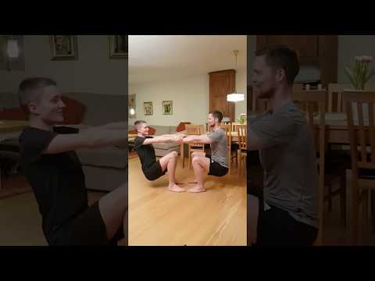
family.fit mobile video

Please Stay Connected
We hope you have enjoyed this booklet of family.fit. It has been put together by volunteers from around the world. You will find all new family.fit sessions on the website https://family.fit
The website has the latest information, ways you can feedback your thoughts and is the place to stay connected with family.fit!
If you enjoyed this, please share with your friends and others you know who might like to participate.
This resource is given freely and meant to be freely given to others at no cost.
If you translate this into your language, please share it back on the website or email it to info@family.fit so it can be shared with others.
Thank you.
The family.fit team

- ourage.

Web: www.family.fit
Email: info@family.fit
Web: www.family.fit
Email: info@family.fit

