family.fitness.faith.fun

How can I encourage others?

A vaccine for isolated days!
Help your family be fit and healthy, stay connected, and grow in character.
6
WEEK

www.family.fit
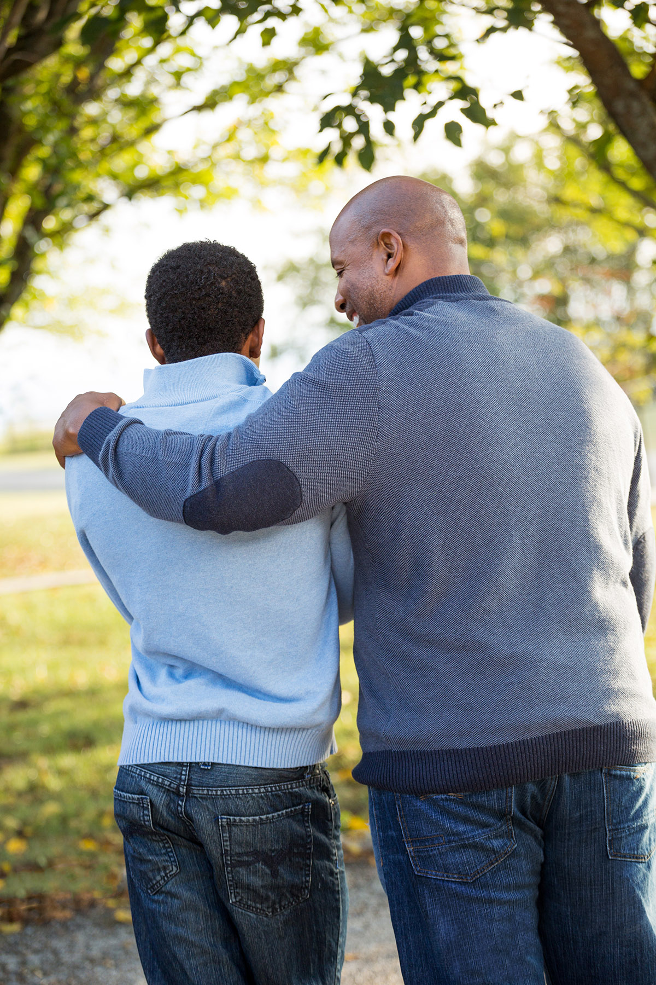

How to make fitness
an important part of your family’s life:

Make it fun
- Be active together
Do exercise a few times a week.
Find a time that will work for everyone.

- Play games
- Involve everyone in the household
- Go inside or outside
- Be creative and improvise with what you have

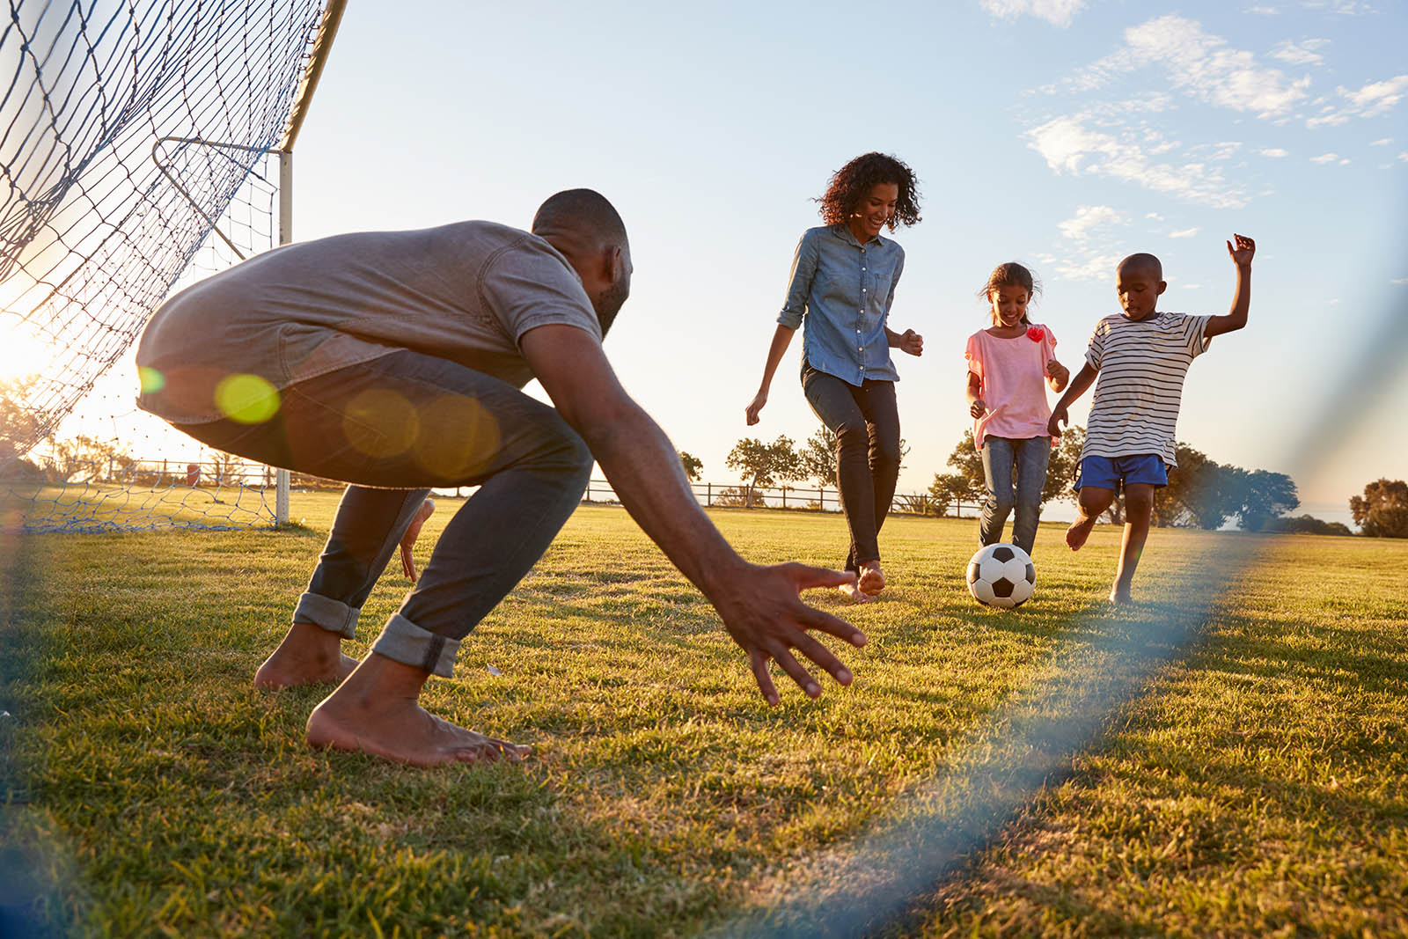
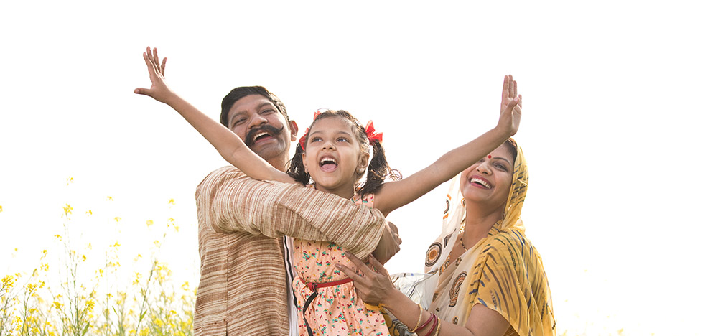

Challenge each other
- Allow different levels of challenge according to ability, size and age
Set personal
goals.
Compare improvements with your personal best.
- Respect each other
- Listen actively
- Share family.fit! It’s free.
- Don’t do exercises that cause pain or make any existing pain worse.
- Don’t exercise if you are sick. Wash hands before and after family.fit.
IMPORTANT AGREEMENT BEFORE USING THIS RESOURCE
By using this resource you agree to our Terms and Conditions https:/family.fit/terms-and-conditions/ as detailed in full on our website. These govern your use of this resource by you and all those exercising with you. Please ensure that you and all those exercising with you accept these terms and conditions in full. If you disagree with these terms and conditions or any part of these terms and conditions, you must not use this resource.

This Week

Theme: Encouragement
How this works
As a family, do some physical exercise 3 days a week (though even once is helpful!). If you can do it more often, then do other types of exercise too – walking, jogging, riding, skating, or swimming.
Each week of family.fit has a theme. The focus this week is on being an encourager. Each step below helps you explore the theme together.
Each session is an adventure made up of 7 steps.
There are 3 options for each step, giving 3 days of exercise programming.
7 Steps of family.fit
- Warm-up
- Talk
- Move
- Challenge
- Explore
- Pray
- Play

Remember anyone in the household can take the phone and lead a different step in the adventure.
Have fun together!

Step 1 | Warm-up

Start moving the whole body 5 min
Do the following whole body warm-ups.
Get moving
DAY 1
Do the following (then repeat):
20 jumping jacks
20 ski jumps
10 push-ups against a wall/fence
10 high jumps
Watch video
Tidy up to music
DAY 2
2
Put on a favorite up-tempo song. As the music plays, everyone moves quickly to pick up things and put them away for about 4 minutes.
Arm circles and body shapes
DAY 3

Arm circles: Stand in a circle and at together complete 15 of each arm movement. Small circles forward, small circles backward, big circles forward, big circles backward.
Body shapes: Lie face down, arms overhead and palms facing each other. Move your arms into each formation.
3 rounds. Watch video

Step 2 | Talk together

Rest and start a conversation 5 min
Sit or stand together and start a short conversation. Here are some questions to get you started.
Discuss
DAY 1
It is so good when someone says or does something that encourages us. What does it mean to be an encourager?
How have you encouraged someone recently? How did it make you feel?
Discuss
DAY 2
2
Think of something that has discouraged you recently or right now.
Share your feelings about what happened. What would make you feel better/encouraged?
Discuss
DAY 3

Talk about something you can do to encourage someone outside your family who may need it.
What could each person do? What could you do as a family? (e.g. bake a cake, write a letter …)

Step 3 | Move

Move and do squats 5 min
Practice 3 movements you have already learned: squats, sit-ups and push-ups.
Practice squats
DAY 1
Let's practice squats from the first week. Do this movement in pairs. Watch Squats video.
Sit-ups and squats
DAY 2
2
Work in pairs. One person does sit-ups then taps to the other person. Alternate between 5 sit-ups
and 5 squats.
Do 5 rounds.
Push-ups
DAY 3

See other versions of the push-up.
Partner high five. Feet on chair.
Watch video.

Step 4 | Challenge

Move in a family challenge 10 min
Challenging each other helps give you energy.
Family challenge - squats
DAY 1
Stand in a circle facing each other. Do 50 squats as a family. One person starts to do squat repetitions. Tap out to the next person when you need a break.
After 50 squats, run as a family to a marker and back. Run to pace of slowest runner. Then start squats again. Do three rounds of 50.
Watch video
Family sit-ups
DAY 2
2
Sit in a circle facing each other. Do 50 sit-ups as a family. One person starts to do sit-up repetitions. Tap out to the next person when you need a break.
After 50 sit-ups, run as a family to a marker and back. Run to pace of slowest runner. Then start sit-ups again. Do 3 rounds of 50.
Watch video

Family challenge
DAY 3

You will need 10 items (eg. toys, socks, shoes). Place them in the middle of your circle. On GO, the first person does 5 push-ups and then removes one of the items. Tap out to the next person. The goal is to empty the pile, then 'refill' the pile. 5 push-ups equals 1 item in the pile.
Watch Video

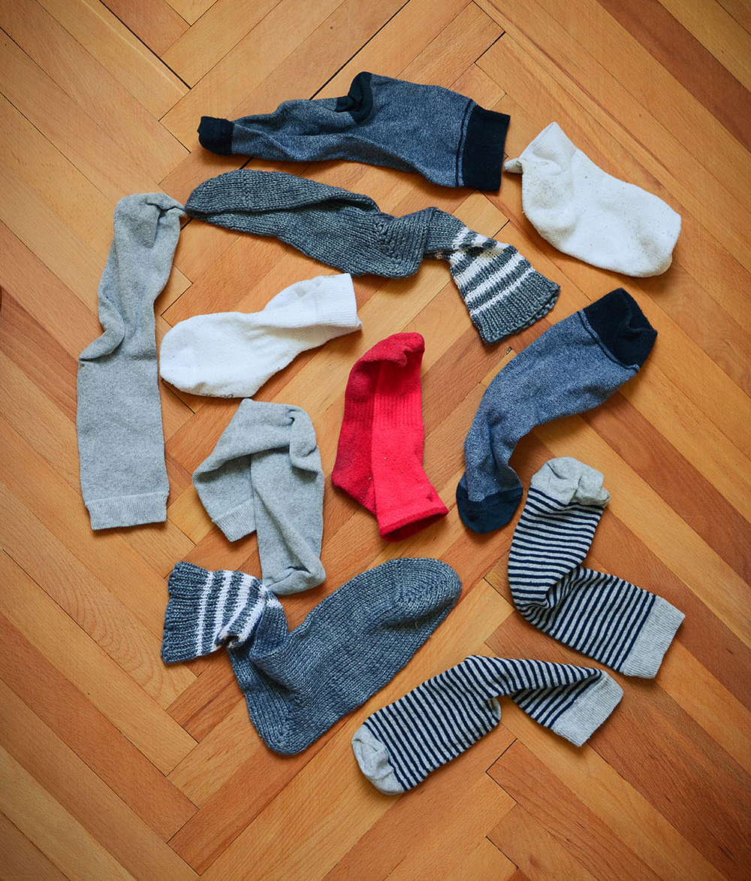

Step 5 | Explore

Explore the Bible together 5 min
Explore the Life Question – “How can I encourage others?” Read 1 Thessalonians 5:11 (next page).
Read and discuss together
DAY 1
Talk about what it looks like when you encourage someone.
Are you an encourager? Score yourself from 1-10 and give your reason. Why is it necessary and important to be an encourager?
Reread the Bible verse
DAY 2
2
Say something to each person in your family that will uplift them.
Create a poster with the words "Encourage one another and build each other up" and put it somewhere noticeable as a reminder.
Reread and discuss together
DAY 3

Share examples of being an encourager from the Bible or from real life.
Build a human pyramid and recite “Encourage one another and build each other up” when it is done.

Scripture about
Being an encourager
The following verse comes from a letter written by the apostle Paul to the church in Thessalonica to remind them about the power of encouragement. If you want to read more visit BibleGateway (or download the Bible App).
In a part of the Bible that asks us to think about the times, the seasons, and the future, we read these words:
“Therefore encourage one another and build each other up, just as in fact you are doing.” (NIV)
Another translation of the Bible puts it this way:
“… speak encouraging words to one another. Build up hope so you’ll all be together in this, no one left out, no one left behind. I know you’re already doing this; just keep on doing it.”
1 Thessalonians 5:11 (MSG)

Step 6 | Pray

Pray and cool down 5 min
Take time to look outwards and pray for others.
Picture prayers
DAY 1
Put a picture of each person in the family into a container. Shake it up. Each person picks out one picture and prays for that member of the family.
Prayer cards
DAY 2
2
Stick the pictures from day 1 onto separate cards. Everyone writes a prayer or a word of encouragement on each card. Include something you appreciate about that family member, decorate it, and hand it to them.
Pray and Encourage
DAY 3

Pray for friends or family outside your household who need encouragement.
Put together a video clip/ voice clip/poster/card from your family and send it them.

Step 7 | Play together

Play games as a family 5 min
Play together in active challenges. Have fun!
Throw the ball challenge
DAY 1
Everyone makes a paper ball and practices throwing and catching with one hand. Then stand in a circle and throw your ball to the right at the same time as you catch the ball from the left. Encourage each other. Watch video
Walk the line challenge
DAY 2
2
Make some lines on the floor (straight, zigzag, or curvy). Use clothes, tape, chalk or ribbon. Each person must move along the line a different way while others follow (hopping, backwards etc). Turn on the music and take turns to set different challenges. Watch video
Treasure hunt
DAY 3

One person hides something at home that will be recognized by the rest of the family. Give a clue to encourage others to find the missing object. Repeat with a new object.

Terminology
- A warm-up is a simple action that gets muscles warm, breathing deeper, and blood pumping. Play fun, up-tempo music for your warm-up activities. Do a range of movements for 3-5 minutes.
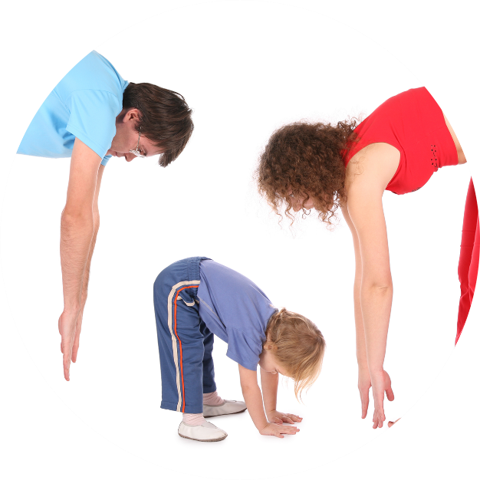
- Workout movements can be seen on the videos so you can learn the new exercise and practice it well. Starting slowly with a focus on technique will enable you to go faster and stronger later.
- Stretches are less likely to cause injury when done AFTER warm-ups. Use a slower piece of music to do stretches. Stretch gently – and hold for 5 seconds.
- Rest and recover after energetic movement. Conversation is great here.
- Tap out is a way to pass the exercise on to the next person. You can choose different ways to “tap out” e.g. hand clap, whistle, finger guns, wink etc. You make it up!

Video links
Find all the videos for family.fit at https://family.fit/ or at the family.fit YouTube® channel

family.fit promo video
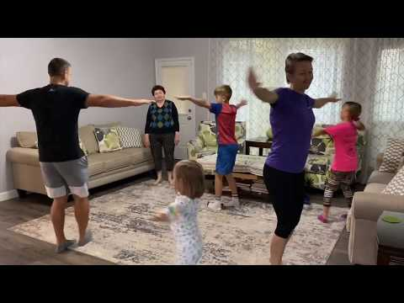
family.fit video
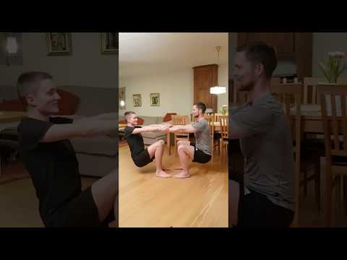
family.fit mobile video

Please Stay Connected
We hope you have enjoyed this booklet of family.fit. It has been put together by volunteers from around the world. You will find all new family.fit sessions on the website https://family.fit
The website has the latest information, ways you can feedback your thoughts and is the place to stay connected with family.fit!
If you enjoyed this, please share with your friends and others you know who might like to participate.
This resource is given freely and meant to be freely given to others at no cost.
If you translate this into your language, please share it back on the website or email it to info@family.fit so it can be shared with others.
Thank you.
The family.fit team

- ourage.

Web: www.family.fit
Email: info@family.fit
Web: www.family.fit
Email: info@family.fit

