family.fitness.faith.fun

How can I be generous?

A vaccine for isolated days!
Help your family be fit and healthy, stay connected, and grow in character.
7
WEEK

www.family.fit

How to make fitness
an important part of your family’s life:

Make it fun
- Be active together
Do exercise a few times a week.
Find a time that will work for everyone.

- Play games
- Involve everyone in the household
- Go inside or outside
- Be creative and improvise with what you have

Two Great Ideas
#2: Think of a family who has never
done family.fit.
Do it together
on Zoom® or WhatsApp® video.

#1: Take a photo
of your family doing family.fit together and post on social media. Tag with #family.fit

Challenge each other
- Allow different levels of challenge according to ability, size and age
Set personal
goals.
Compare improvements with your personal best.
- Respect each other
- Listen actively
- Share family.fit! It’s free.
- Don’t do exercises that cause pain or make any existing pain worse.
- Don’t exercise if you are sick. Wash hands before and after family.fit.
IMPORTANT AGREEMENT BEFORE USING THIS RESOURCE
By using this resource you agree to our Terms and Conditions https:/family.fit/terms-and-conditions/ as detailed in full on our website. These govern your use of this resource by you and all those exercising with you. Please ensure that you and all those exercising with you accept these terms and conditions in full. If you disagree with these terms and conditions or any part of these terms and conditions, you must not use this resource.

This Week

Theme: Generosity
How this works
As a family, do some physical exercise 3 days a week (though even once is helpful!). If you can do it more often, then do other types of exercise too – walking, jogging, riding, skating, or swimming.
Each week of family.fit has a theme. The focus this week is on being generous. Each step below helps you explore the theme together.
Each session is an adventure made up of 7 steps.
There are 3 options for each step, giving 3 days of exercise programming.
7 Steps of family.fit
- Warm-up
- Talk
- Move
- Challenge
- Explore
- Pray
- Play

Remember anyone in the household can take the phone and lead a different step in the adventure.
Have fun together!

Step 1 | Warm-up

Start moving the whole body 5 min
Do the following whole body warm-ups.
Get moving
DAY 1
One person is leader for each round. Start by jogging around. The leader says a name and the family must move like this. Mix them up. Watch video
Mr. Slow - move slowly
Mr. Rush - move fast
Mr. Jelly - shake your whole body
Mr. Muddle - walk backwards
Mr. Bounce - hop around
Mr. Small - crouch and keep moving
Mr. Strong - move flexing your muscles
Mr. Tall - stretch up and move
Mr. Tickle - wave your arms around
Mr. Happy - move and smile
Tic-Tac-Toe
DAY 2
2
Work in two teams. Each team is given a challenge. Eg 10 jumping jacks. When completed, two people run and place their piece on the tic-tac-toe game. Continue with new challenges.
Watch video
Get moving
DAY 3

Repeat day 1.

Step 2 | Talk together

Rest and start a conversation 5 min
Sit or stand together and start a short conversation. Here are some questions to get you started.
Discuss
DAY 1
What does it mean to be generous?
Being generous is not just about money. In what other ways can we be generous? What is the opposite of being generous?
Discuss
DAY 2
2
Share some examples of generosity you have seen or experienced.
What do you think the generous person felt? And the one receiving it?
Discuss
DAY 3

Can you think of a time when you were generous as a family? What did it feel like? Do you see an opportunity now where you can be generous as a family?

Step 3 | Move

Move and do superman 5 min
Practice the superman movement to develop core strength.
Practice superman
DAY 1
Lie face down on the floor or on a mat with your arms stretched above your head (like Superman).
Raise your arms and legs about 6 inches/15 cm off the ground (or as far as you comfortably can).
Hold for 3 seconds and slowly come back to the floor and relax.
Watch video
Superman variation
DAY 2
2
One Arm/Leg at a time.
Lie face down on a mat with your arms stretched above your head (like Superman).
Raise your right arm and left leg about 6 inches/15 cm off the ground (or as far as you comfortably can).
Hold for 3 seconds and relax.
Repeat with the opposite arm and leg.
Watch video
Harder superman
DAY 3

Lie face down on a mat with your arms stretched above your head (like Superman).
Extend your arms and legs so far in opposite directions that they naturally come up off the floor.
Pump your right arm and left leg up and down in a small pulse, continuing to reach out from your center. Alternate right arm/left leg and left arm/right leg pulses.
Watch video

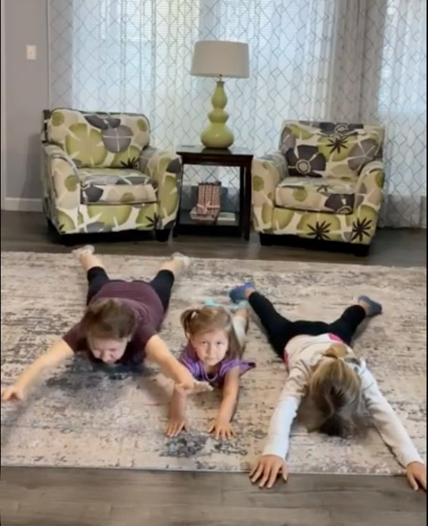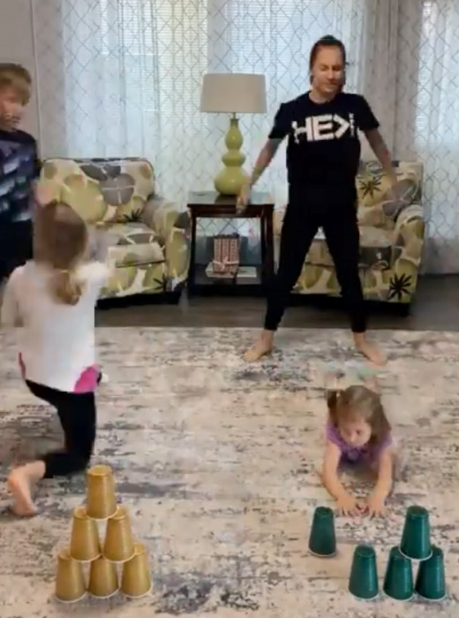
Superman (left) and Family Challenge cups (right)

Step 4 | Challenge

Move in a family challenge 10 min
Challenging each other helps give you energy.
Family challenge
DAY 1
Work in pairs. 6 cups per pair.
One person holds superman while the other does 5 squats. After each round place 1 cup to build a tower.
Swap roles. 6 rounds.
Try to build your tower as fast as possible each time. Watch video (photo on previous page).
Superman roll
DAY 2
2
Everyone takes turns to roll in the superman position from one side of the room to the other while carrying a cup. Roll without your hands and feet touching the floor. Continue as you build a tower of cups.
Choose the size of the tower by the number of cups you use. Watch video
Family challenge
DAY 3

Repeat day 1.
Take a photo of the family challenge and post on social media. Tag with #family.fit

Step 5 | Explore

Explore the Bible together 5 min
Explore the Life Question – “How can I be generous?” Read John 12:1-8 (next page).
Read and discuss together
DAY 1
Find some perfume and smell it as you talk about the generosity in this story.
Who was generous and why? Why was it put on Jesus’ feet?
What was Jesus’ response to this?
Reread the Bible verse
DAY 2
2
God is generous! Write down some of the things God has given each of you on separate pieces of paper.
Find a spare jar or pot to put them in.
Reread and discuss together
DAY 3

What is God saying to you through this story? Share some of the ways friends or family have been generous to you.
Prepare a surprise gift for someone in your family or someone else you know.

Scripture about
being generous
The following story comes from chapter 12 of the Book of John in the Bible. Jesus was having a meal with good friends who were very grateful to Him. If you want to read more visit BibleGateway (or download the Bible App).
Six days before Passover Jesus went back to Bethany, where he had raised Lazarus from death. A meal had been prepared for Jesus. Martha was doing the serving, and Lazarus himself was there. Mary took a very expensive bottle of perfume and poured it on Jesus' feet. She wiped them with her hair, and the sweet smell of the perfume filled the house. A disciple named Judas Iscariot was there. He was the one who was going to betray Jesus, and he asked, “Why wasn’t this perfume sold for three hundred silver coins and the money given to the poor?” Judas did not really care about the poor. He asked this because he carried the moneybag and sometimes would steal from it. Jesus replied, “Leave her alone! She has kept this perfume for the day of my burial. You will always have the poor with you, but you won’t always have me.”
John 12:1-8 (CEV)

Step 6 | Pray

Pray and cool down 5 min
Take time to look outwards and pray for others.
Pray and stretch
DAY 1
Use the letters from the word ‘GENEROSITY’ to make a list of some things that God has generously given to you as a family. Thank Him together.
Short prayers
DAY 2
2
Take your pot from STEP 5 and pray one-line prayers thanking God for His generosity. Ask God to help you to be generous in the things where you know you need help.
Pray and surprise
DAY 3

Ask God to help you think of someone you know who would not be expecting anything from you and surprise them with something (gift/food/time) to encourage them. Pray that they will be blessed as they receive it.

Step 7 | Play together

Play games as a family 5 min
Play together in active challenges. Have fun!
The best score is …
DAY 1
Place cups on a table with a target score on each. From a distance of 3-4 meters throw 5 paper balls towards the cups. Score points for each ball in a cup. After 5 rounds see who gets the best score.
Watch video
Sort them
DAY 2
2
Put a number of small random objects (eg. seeds, coins, marbles, pasta etc) into a dish for each person. On GO, sort them into different cups. See who has the best time.
Watch video
Balance and walk
DAY 3

Each person balances a book on their head and walks to the other side of the room and back without touching it.
Try it backwards.
Then try a book and a plastic cup.

Terminology
- A warm-up is a simple action that gets muscles warm, breathing deeper, and blood pumping. Play fun, up-tempo music for your warm-up activities. Do a range of movements for 3-5 minutes.
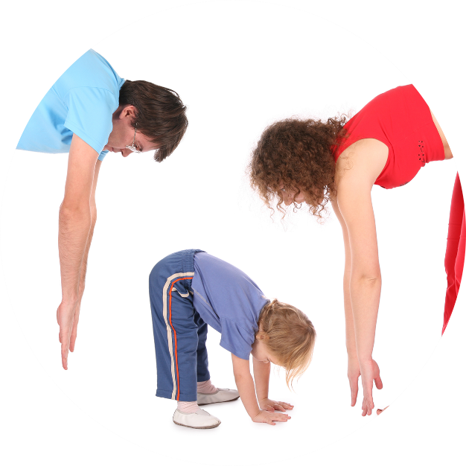
- Workout movements can be seen on the videos so you can learn the new exercise and practice it well. Starting slowly with a focus on technique will enable you to go faster and stronger later.
- Stretches are less likely to cause injury when done AFTER warm-ups. Use a slower piece of music to do stretches. Stretch gently – and hold for 5 seconds.
- Rest and recover after energetic movement. Conversation is great here.
- Tap out is a way to pass the exercise on to the next person. You can choose different ways to “tap out” e.g. hand clap, whistle, finger guns, wink etc. You make it up!

Video links
Find all the videos for family.fit at https://family.fit/ or at the family.fit YouTube® channel

family.fit promo video
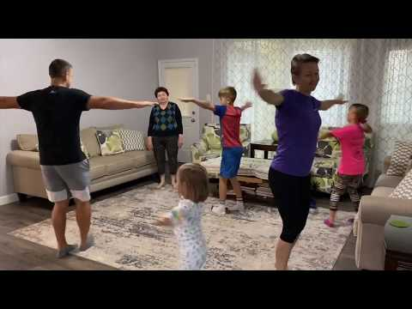
family.fit video
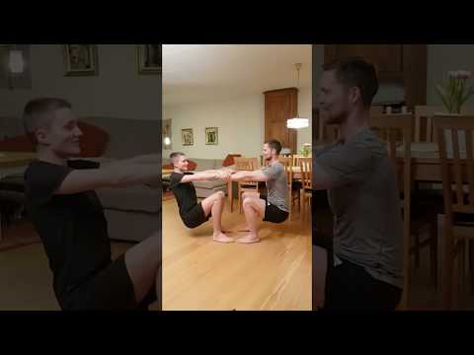
family.fit mobile video

Please Stay Connected
We hope you have enjoyed this booklet of family.fit. It has been put together by volunteers from around the world. You will find all new family.fit sessions on the website https://family.fit
The website has the latest information, ways you can feedback your thoughts and is the place to stay connected with family.fit!
If you enjoyed this, please share with your friends and others you know who might like to participate.
This resource is given freely and meant to be freely given to others at no cost.
If you translate this into your language, please share it back on the website or email it to info@family.fit so it can be shared with others.
Thank you.
The family.fit team

- ourage.

Web: www.family.fit
Email: info@family.fit
Web: www.family.fit
Email: info@family.fit

