family.fitness.faith.fun

How can I be a good friend?

A vaccine for isolated days!
Help your family be fit and healthy, stay connected, and grow in character.
8
WEEK

www.family.fit

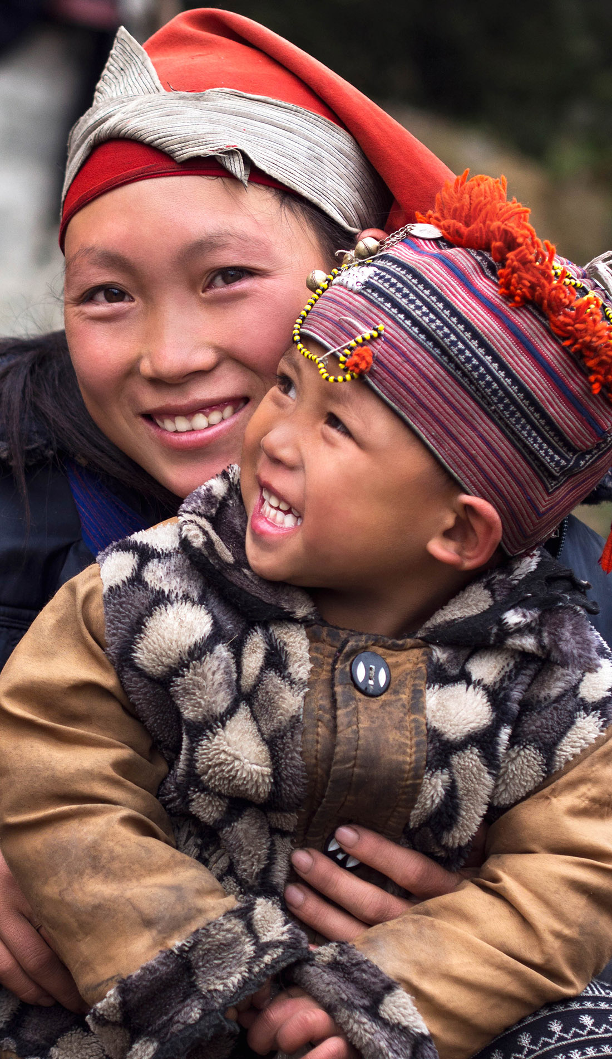

How to make fitness
an important part of your family’s life:

Make it fun
- Be active together
Do exercise a few times a week.
Find a time that will work for everyone.

- Play games
- Involve everyone in the household
- Go inside or outside
- Be creative and improvise with what you have

Two Great Ideas
#2: Think of a family who has never
done family.fit.
Do it together
on Zoom® or WhatsApp® video.

#1: Take a photo
of your family doing family.fit together and post on social media. Tag with #family.fit

Challenge each other
- Allow different levels of challenge according to ability, size and age
Set personal
goals.
Compare improvements with your personal best.
- Respect each other
- Listen actively
- Share family.fit! It’s free.
- Don’t do exercises that cause pain or make any existing pain worse.
- Don’t exercise if you are sick. Wash hands before and after family.fit.
IMPORTANT AGREEMENT BEFORE USING THIS RESOURCE
By using this resource you agree to our Terms and Conditions https://family.fit/terms-and-conditions/ as detailed in full on our website. These govern your use of this resource by you and all those exercising with you. Please ensure that you and all those exercising with you accept these terms and conditions in full. If you disagree with these terms and conditions or any part of these terms and conditions, you must not use this resource.

This Week

Theme: Friendship
How this works
As a family, do some physical exercise 3 days a week (though even once is helpful!). If you can do it more often, then do other types of exercise too – walking, jogging, riding, skating, or swimming.
Each week of family.fit has a theme. The focus this week is on being a good friend. Each step below helps you explore the theme together.
Each session is an adventure made up of 7 steps.
There are 3 options for each step, giving 3 days of exercise programming.
7 Steps of family.fit
- Warm-up
- Talk
- Move
- Challenge
- Explore
- Pray
- Play

Remember anyone in the household can take the phone and lead a different step in the adventure.
Have fun together!

Step 1 | Warm-up

Start moving the whole body 5 min
Do the following whole body warm-ups.
Bear and crab walks
DAY 1
Bear walk across the room and crab walk back. 5 laps.
Bear walk – Walk face down with feet and hands on the floor.
Crab walk – Walk face up with feet and hands on the floor.
Watch video
Warm up to music
DAY 2
2
Do the following (then repeat):
20 running on the spot
5 squats
20 high knees running
5 to the floor - to the sky
Watch video
Hip race
DAY 3

Move across the room and back. Sit on the floor and move forwards using your hands and feet. Then move backwards in the same way. 5 fast laps.
Watch video

Step 2 | Talk together

Rest and start a conversation 5 min
Sit or stand together and start a short conversation. Here are some questions to get you started.
Discuss
DAY 1
If you could meet and become friends with anyone from history, who would you choose? Why?
What do you value most in a friendship? Share examples from your own experience.
Discuss
DAY 2
2
If you could meet and become friends with an artist or athlete, who would you choose? Why?
What do you think can damage a good friendship? Has this ever happened to you?
Discuss
DAY 3

If you could become friends with a cartoon character, who would you choose? How would you spend time with them? Be creative!
Rate yourself as a friend from 1 to 10. Why do you think that?

Step 3 | Move

Move and do dips 5 min
Practice the dips movement to develop arm strength.
Practice floor dips
DAY 1
Practice two movements.
3 rounds of 10.
1. Sit on the floor with hands as supports and legs extended. Then raise your hips, keeping your hands and heels on the floor.
2. Lean back on the floor resting on your elbows. Use arms to push up into a sitting position. Watch video
Chair dips
DAY 2
2
Dip on a chair by supporting your weight on your arms. Keep feet on the floor. 10 reps.
Watch video
Harder dips
DAY 3

Dip on a chair by supporting your weight on your arms. As you dip, extend one leg off the floor. Alternate legs. Watch video

Step 4 | Challenge

Move in a family challenge 10 min
Challenging each other helps give you energy.
Family relay challenge
DAY 1
Using a chair, each person does 3 dips and then runs to a marker to scoop water into a glass using a spoon. Tag the next person to continue. Keep going until the glass is full.
3 dips = 1 spoon.
Watch video
Dips challenge
DAY 2
2
Set a challenging family target of a total number of dips. Eg 50 dips.
If the family beats the target, everyone gets some delicious fruit.
Watch video
One leg dip challenge
DAY 3

See how many one-legged dips the family can do in 90 seconds.
Do the dips with one leg extended and alternate the legs.
Watch video

Step 5 | Explore

Explore the Bible together 5 min
Explore the Life Question – “How can I be a good friend?” Read Proverbs 17:17-22.
Read and talk about verse 17
DAY 1
What does it mean to love a person?
The last part of the verse talks about difficult times. What do we discover about someone’s love for us in hard situations? How you can love someone going through a tough time? List some ideas on paper.
Read and talk about verse 19
DAY 2
2
We build walls between us when we quarrel and take offence. Why? Make a barrier out of furniture. One person stands one side and the rest stand on the other. Talk about breaking down barriers through forgiveness.
Friendships need to be nurtured. How can we do that? Make a poster of ideas as a family.
Read and talk about verse 22
DAY 3

Everyone goes through difficult situations. What can we bring to their lives to make a difference?
Who could you encourage today? How? Who has been ‘good medicine’ to you? Take time to write them a note.

Scripture about
being a good friend
The following story comes from chapter 17 of the Book of Proverbs in the Bible. Proverbs is a collection of wise sayings which help us to live in a way which is pleasing to God. If you want to read more visit BibleGateway (or download the Bible App).
Proverbs 17
¹⁷ A friend loves at all times, and a brother is born for a time of adversity.
¹⁸ One who has no sense shakes hands in pledge and puts up security for a neighbor.
¹⁹ Whoever loves a quarrel loves sin;
whoever builds a high gate invites destruction.
²⁰ One whose heart is corrupt does not prosper; one whose tongue is perverse falls into trouble.
²¹ To have a fool for a child brings grief;
there is no joy for the parent of a godless fool.
²² A cheerful heart is good medicine,
but a crushed spirit dries up the bones.

Step 6 | Pray

Pray and cool down 5 min
Take time to look outwards and pray for others.
Pray and stretch
DAY 1
Draw or list the friends you have. Thank God for them. Pray that you can be a good friend for them too. Think about specific ways to surprise them and thank them!
Stretch as you pray for them.
Restoration prayers
DAY 2
2
Perhaps you have said or done something that has hurt another. Ask God for help as you admit your mistakes and ask for forgiveness. Speak to them about it. It will take courage!
Pray for others
DAY 3

Thank God that He is your friend who wants what is best for you and is always there for you. Ask God to help you to be that kind of friend for others. Think of 2 or 3 people you can cheer up this week through your friendship. Pray for them - then go and surprise them!

Step 7 | Play together

Play games as a family 5 min
Play together in active challenges. Have fun!
Around the world table tennis
DAY 1
Stand around a table. One person hits a ball over a “net” and another person returns it. Keep moving so that each person has a turn - pass the bat to the next in line. Try to make 10 consecutive hits as a family, then 20.
Notes: Use creativity! Instead of rackets use plastic lids/plates or flip flops. Instead of a net you can use books or toilet paper rolls. Watch video
Ball in the goal
DAY 2
2
Divide the family into two teams, one on each side of a table. Place a row of toilet paper rolls or cups in the middle of the table.
See which team can be first to score and get the ball in.
Watch video
Build a play house
DAY 3

Have fun with your family building a fort/castle/tent inside. Be creative.

Terminology
- A warm-up is a simple action that gets muscles warm, breathing deeper, and blood pumping. Play fun, up-tempo music for your warm-up activities. Do a range of movements for 3-5 minutes.
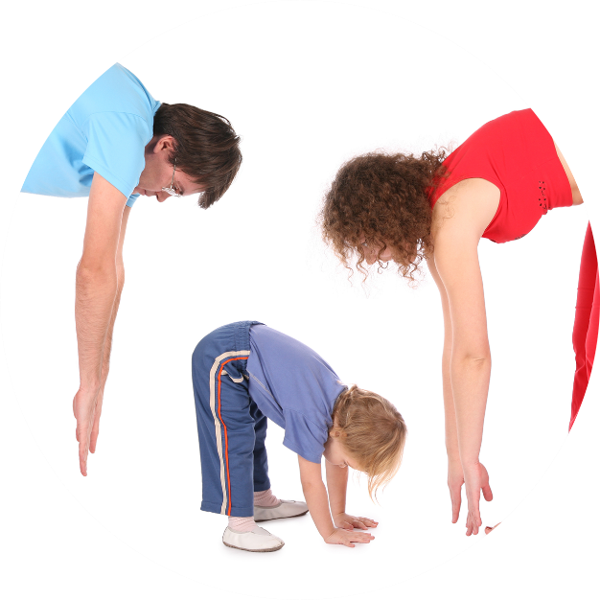
- Workout movements can be seen on the videos so you can learn the new exercise and practice it well. Starting slowly with a focus on technique will enable you to go faster and stronger later.
- Stretches are less likely to cause injury when done AFTER warm-ups. Use a slower piece of music to do stretches. Stretch gently – and hold for 5 seconds.
- Rest and recover after energetic movement. Conversation is great here.
- Tap out is a way to pass the exercise on to the next person. You can choose different ways to “tap out” e.g. hand clap, whistle, finger guns, wink etc. You make it up!

Video links
Find all the videos for family.fit at https://family.fit/ or at the family.fit YouTube® channel

family.fit promo video
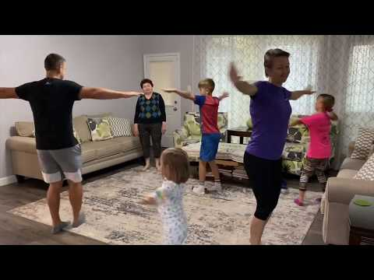
family.fit video
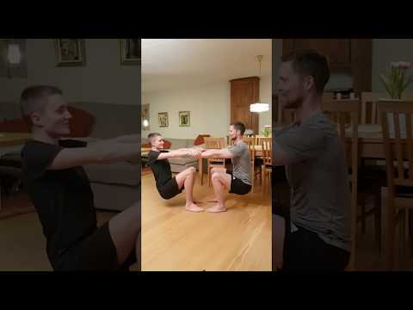
family.fit mobile video

Please Stay Connected
We hope you have enjoyed this booklet of family.fit. It has been put together by volunteers from around the world. You will find all new family.fit sessions on the website https://family.fit
The website has the latest information, ways you can feedback your thoughts and is the place to stay connected with family.fit!
If you enjoyed this, please share with your friends and others you know who might like to participate.
This resource is given freely and meant to be freely given to others at no cost.
If you translate this into your language, please share it back on the website or email it to info@family.fit so it can be shared with others.
Thank you.
The family.fit team

- ourage.

Web: www.family.fit
Email: info@family.fit
Web: www.family.fit
Email: info@family.fit

