family.fitness.faith.fun

Do I wonder about life?

A vaccine for isolated days!
Help your family be fit and healthy, stay connected, and grow in character.
9
WEEK

www.family.fit

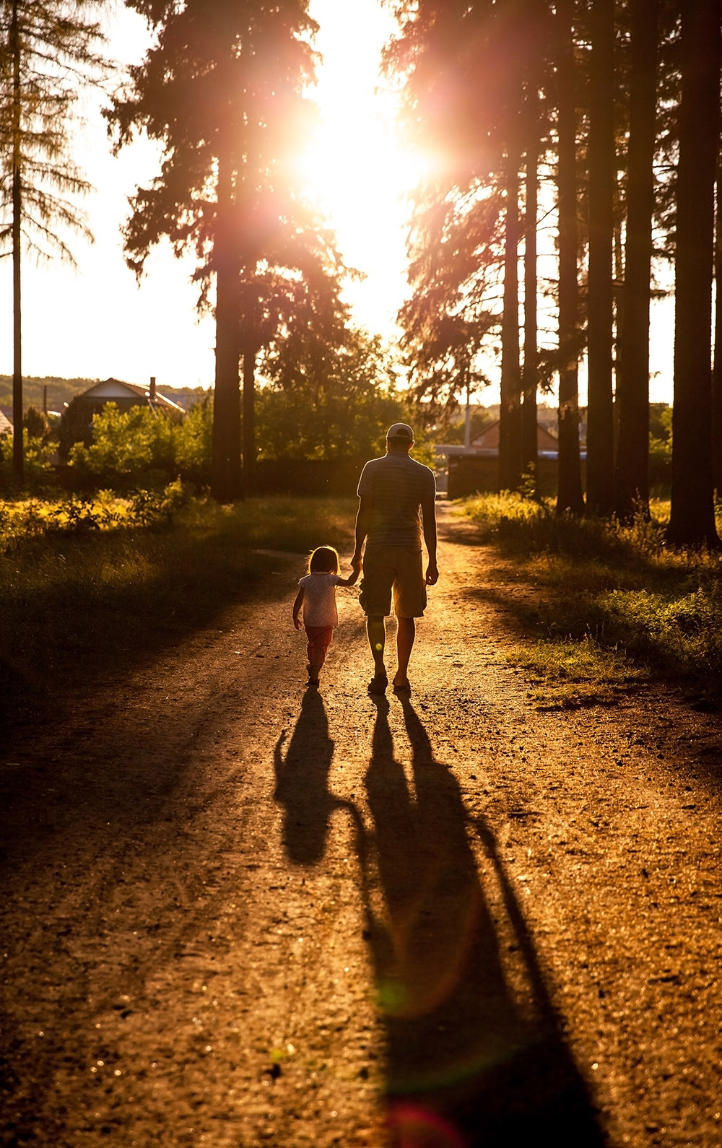

How to make fitness
an important part of your family’s life:

Make it fun
- Be active together
Do exercise a few times a week.
Find a time that will work for everyone.

- Play games
- Involve everyone in the household
- Go inside or outside
- Be creative and improvise with what you have

Two Great Ideas
#2: Think of a family who has never
done family.fit.
Do it together
on Zoom® or WhatsApp® video.

#1: Take a photo
of your family doing family.fit together and post on social media. Tag with #family.fit

Challenge each other
- Allow different levels of challenge according to ability, size and age
Set personal
goals.
Compare improvements with your personal best.
- Respect each other
- Listen actively
- Share family.fit! It’s free.
- Don’t do exercises that cause pain or make any existing pain worse.
- Don’t exercise if you are sick. Wash hands before and after family.fit.
IMPORTANT AGREEMENT BEFORE USING THIS RESOURCE
By using this resource you agree to our Terms and Conditions https:/family.fit/terms-and-conditions/ as detailed in full on our website. These govern your use of this resource by you and all those exercising with you. Please ensure that you and all those exercising with you accept these terms and conditions in full. If you disagree with these terms and conditions or any part of these terms and conditions, you must not use this resource.

This Week

Theme: Wonder
How this works
As a family, do some physical exercise 3 days a week (though even once is helpful!). If you can do it more often, then do other types of exercise too – walking, jogging, riding, skating, or swimming.
Each week of family.fit has a theme. The focus this week is on wondering. Each step below helps you explore the theme together.
Each session is an adventure made up of 7 steps.
There are 3 options for each step, giving 3 days of exercise programming.
7 Steps of family.fit
- Warm-up
- Talk
- Move
- Challenge
- Explore
- Pray
- Play

Remember anyone in the household can take the phone and lead a different step in the adventure.
Have fun together!

Watch video

Step 1 | Warm-up

Start moving the whole body 5 min
Do the following whole body warm-ups.
Warm-up to music
DAY 1
Do the following for 60 seconds each:
High knees running
High knees to side
Scissor jumps
Jumping jacks
Watch video
Junkyard dog
DAY 2
2
One person sits on the floor with legs out to the front and arms out to the side. The others jump over the arm, the legs and the second arm. Everybody jumps 2 rounds and changes places so everybody gets to jump.
Watch video
Warm-up to music
DAY 3

Repeat day 1

Step 2 | Talk together

Rest and start a conversation 5 min
Sit or stand together and start a short conversation. Here are some questions to get you started.
Discuss
DAY 1
How do you feel when you look at the night sky?
How many stars do you think are in the universe? What is the biggest number you can think of?
Wonder together why God made so many stars.
Discuss
DAY 2
2
Think of a famous person and share what you like about them.
Do they know who you are?
Who are the people who care about you, and know what makes you special?
Discuss
DAY 3

Do you have a pet animal or would you like one?
Do you have a garden or would you like one?
What responsibilities are involved in having a pet or a garden?

Step 3 | Move

Move and do speed skaters 5 min
Practice the speed skaters movement to develop leg and core strength.
Practice speed skaters
DAY 1
Practice speed skaters. Do 10 of them. Rest and then do 20. Rest, then do 30.
Watch video
Tabata
DAY 2
2
Do as many speed skaters as you can for 20 seconds, rest 10 seconds, and then repeat 8 times.
Try and do the same number in each round. Listen to tabata music
Harder speed skaters
DAY 3

Practice harder speed skaters. Make them smooth and increase speed. Do 20. Rest and then do 20 again.
Try 20 speed skaters over an object. Rest and then do 20 again.
Watch video

Step 4 | Challenge

Move in a family challenge 10 min
Challenging each other helps give you energy.
Obstacle course
DAY 1
Set up an obstacle course. Use the space you have inside or outside (e.g. run to the tree/chair, leap over the path/rug, etc.) Be creative!
Take turns to get through the obstacle course as quickly as possible. Time each person. Watch Video
Knee tag
DAY 2
2
Compete in pairs. Try to touch your opponent’s knees as many times as you can in 60 seconds while you protect your own with your hands and body position. Change partners.
Watch video
Family challenge
DAY 3

Stand in a circle. Do 100 speed skaters as a family. One person starts and then taps out to the next person when needed. After 100, rest for 30 seconds and then start speed skaters again.
3 rounds of 100.

Step 5 | Explore

Explore the Bible together 5 min
Explore the Life Question – “Do I wonder about life?” Read Psalm 8 (see next page).
Read Psalm 8 and talk
DAY 1
Set a timer for 60 seconds and see who can draw the most stars in that time. What is your family total?
If you counted all the stars, one per second, it would take more than a trillion years! What does this tell you about our Creator God?
Reread and talk
DAY 2
2
The Psalm says God thinks about us and cares for us. Think: I wonder what God is thinking about us today?
Knowing that God cares for and notices you, how does it make you feel? Add words to finish this sentence “I feel …” and make a poster together.
Reread and talk
DAY 3

From the Psalm, what responsibilities does God give to humans?
Do you think humans are doing a good job of taking care of everything God made? (consider verses 7-8)
What is one small or big thing you could do to help? As a family?

Scripture about
wondering about life
The following passage is a song written by King David about 3000 years ago. Even though he was a king, he felt both small and special when he compared himself to God and what He has created. If you want to read more visit BibleGateway (or download the Bible App).
Psalm 8 (ERV)
¹ Lord our Lord, your name is the most wonderful in all the earth!
It brings you praise everywhere in heaven.
² From the mouths of children and babies come songs of praise to you.
They sing of your power to silence your enemies who were seeking revenge.
³ I look at the heavens you made with your hands.
I see the moon and the stars you created.
⁴ And I wonder, “Why are people so important to you?
Why do you even think about them?
Why do you care so much about humans?
Why do you even notice them?”

⁵ But you made them almost like gods
and crowned them with glory and honor.
⁶ You put them in charge of everything you made.
You put everything under their control.
⁷ People rule over the sheep and cattle and all the wild animals.
⁸ They rule over the birds in the sky
and the fish that swim in the sea.
⁹ Lord our Lord, your name is the most wonderful name in all the earth!

Step 6 | Pray

Pray and cool down 5 min
Take time to look outwards and pray for others.
Pray and stretch
DAY 1
While you stretch, take turns sharing something that makes you think of how big and great our God is (like a big mountain or wide ocean) and tell Him how great He is!
Pray and wonder
DAY 2
2
God is big enough to cope with our wondering questions. Finish today by sharing some of your ‘I wonder why …’ questions.
Pray Psalm 8 together
DAY 3

Read Psalm 8 out loud together as a prayer of praise to God.

Step 7 | Play together

Play games as a family 5 min
Play together in active challenges. Have fun!
Mirror mirror
DAY 1
Stand face to face with a partner and have them attempt to copy all your movements. Make it fun. Then swap roles. Watch video
Sharks
DAY 2
2
Scatter some “islands” and “boats” across the floor (use pillows, stuffed animals, towels etc) and then have everyone jump from one to the next without falling into the water and risk being eaten by ‘sharks’.
Watch video
Make an ‘I wonder’ book
DAY 3

Create an "I wonder" book. Let everyone store their big ideas and curious questions in a note book. Maybe research some answers together. Encourage kids to continue to ask questions ever though some answers may be hard to investigate.

Terminology
- A warm-up is a simple action that gets muscles warm, breathing deeper, and blood pumping. Play fun, up-tempo music for your warm-up activities. Do a range of movements for 3-5 minutes.
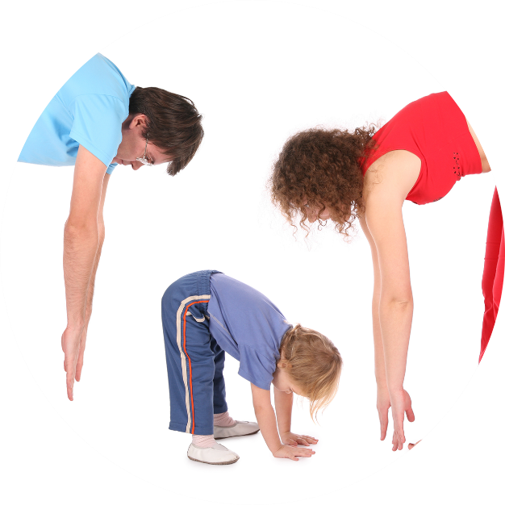
- Workout movements can be seen on the videos so you can learn the new exercise and practice it well. Starting slowly with a focus on technique will enable you to go faster and stronger later.
- Stretches are less likely to cause injury when done AFTER warm-ups. Use a slower piece of music to do stretches. Stretch gently – and hold for 5 seconds.
- Rest and recover after energetic movement. Conversation is great here.
- Tap out is a way to pass the exercise on to the next person. You can choose different ways to “tap out” e.g. hand clap, whistle, finger guns, wink etc. You make it up!

Video links
Find all the videos for family.fit at https://family.fit/ or at the family.fit YouTube® channel

family.fit promo video
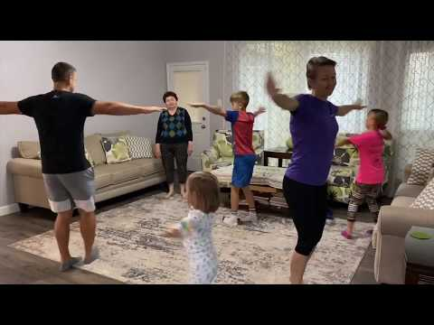
family.fit video
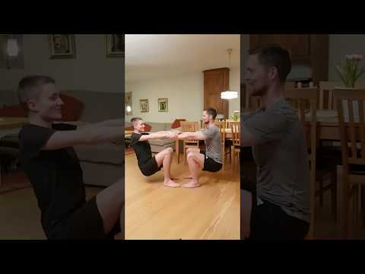
family.fit mobile video

Please Stay Connected
We hope you have enjoyed this booklet of family.fit. It has been put together by volunteers from around the world. You will find all new family.fit sessions on the website https://family.fit
The website has the latest information, ways you can feedback your thoughts and is the place to stay connected with family.fit!
If you enjoyed this, please share with your friends and others you know who might like to participate.
This resource is given freely and meant to be freely given to others at no cost.
If you translate this into your language, please share it back on the website or email it to info@family.fit so it can be shared with others.
Thank you.
The family.fit team

- ourage.

Web: www.family.fit
Email: info@family.fit
Web: www.family.fit
Email: info@family.fit

