10
Week
Help your family be fit and healthy, stay connected, and grow in character.
A vaccine for isolated days!
How can I show compassion?
family.fitness.faith.fun
www.family.fit

How to make fitness an important part of your family’s life:

Make it fun
Do exercise a few times a week.
Find a time that will work for everyone.
- Be active together
- Play games
- Involve everyone in the household
- Go inside or outside
- Be creative and improvise with what you have

#1: Take a photo of your family enjoying family.fit and post on social media. Tag with #familyfit
#2: Think of a family who has never done family.fit. Do it together on Zoom® or WhatsApp® video.

Two great ideas

Challenge each other
- Allow different levels of challenge according to ability, size and age
Set personal goals.
Compare improvements with your personal best.
- Respect each other
- Listen actively
- Share family.fit! It’s free.
- Don’t do exercises that cause pain or make any existing pain worse.
- Don’t exercise if you are sick. Wash hands before and after family.fit.
IMPORTANT AGREEMENT BEFORE USING THIS RESOURCE
By using this resource you agree to our Terms and Conditions https://family.fit/terms-and-conditions/ as detailed in full on our website. These govern your use of this resource by you and all those exercising with you. Please ensure that you and all those exercising with you accept these terms and conditions in full. If you disagree with these terms and conditions or any part of these terms and conditions, you must not use this resource.
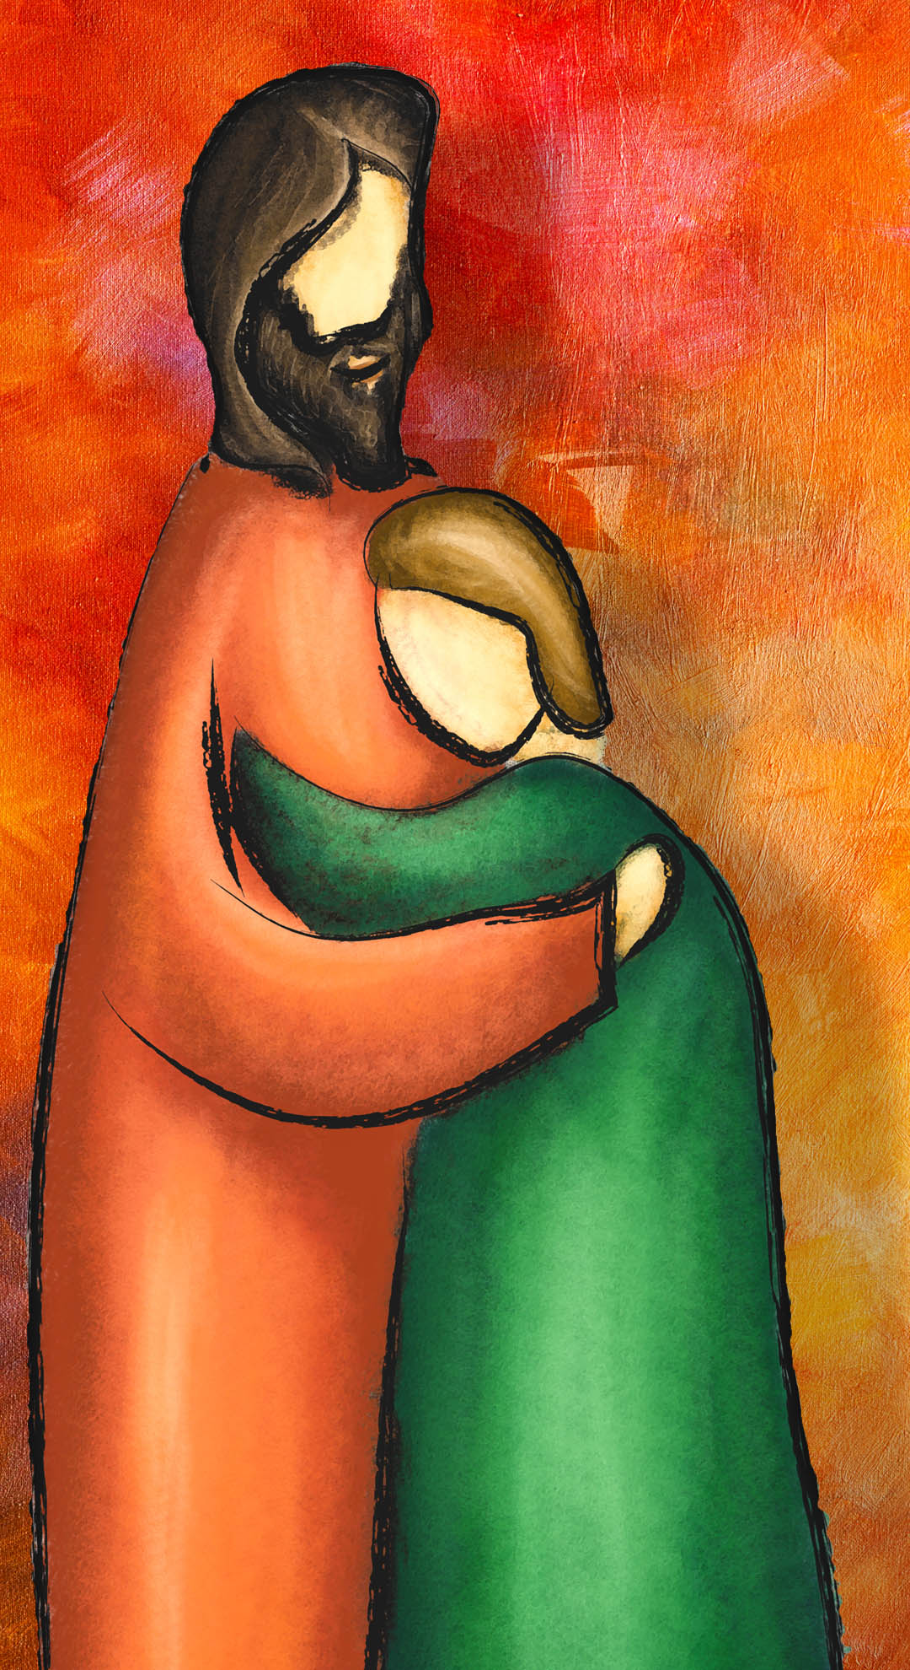

How this works
As a family, do some physical exercise 3 days a week (though even once is helpful!). If you can do it more often, then do other types of exercise too – walking, jogging, riding, skating, or swimming.
Each week of family.fit has a theme. The focus this week is on compassion. Each step below helps you explore the theme together.
7 steps of family.fit

- Warm-up
- Talk
- Move
- Challenge
- Explore
- Pray
- Play

Each session is an adventure made up of 7 steps.
There are 3 options for each step, giving
3 days of exercise programming.
Remember anyone in the household can take the phone and lead a different step in the adventure.
Have fun together!
Watch this video.
Theme: Compassion
This Week
Step 1: Warm-up
Start moving the whole body: 5 minutes

Do the following whole-body warm-ups.
Day 1 — Tail competition
Everyone wears a scarf or small towel as a ‘tail’ tucked in at the back. The goal is to collect as many tails as you can, while protecting your own. If you lose your tail, do five push-ups and continue the game. Have fun.
Watch this video.
Day 2 — Wheelbarrow and inchworm
Wheelbarrow: Work with a partner. Walk 10 meters then swap places.
Inch worm: Bend at the waist and place your hands on the floor. Walk your hands out until you’re in a plank position with a flat back. Then walk your feet as close to your hands as you can. Repeat for 10 meters. Do three rounds.
Watch this video.
Day 3 — Tail competition
Repeat Day 1.

Step 2: Talk together
Rest and start a conversation: 5 minutes

Sit or stand together and start a short conversation. Here are some questions to get you started.
Day 1 — Discuss
Think about a time when you did something selfish. Share this with your family if you can. What are we saying with our actions when we act selfishly?
Day 2 — Discuss
How would you define ‘compassion’? Share an example you have seen of someone being compassionate. Is there a difference between compassion and kindness?
Day 3 — Discuss
Is there someone you know who needs some compassion right now? How could you show this individually? As a family?

Step 3: Move
Move and do push-ups: 5 minutes

Practice push-ups to develop arm, shoulder and core strength.
Day 1 — Scaled push-ups
Practice this movement in pairs. Start slowly and carefully.
Easier: Knees on the ground or hands on a wall.
Harder: Feet on the ground.
Scale up if you can. Do three rounds of 10.
Watch this video.
Day 2 — Reverse push-ups
Stand in a line (smallest at front) with a chair behind the last person. Lean backwards with hands on the knees of the person behind you and legs in front at 90 degrees. The last person leans on a chair. Descend at the same time and return to the starting point.
Repeat 10 times. Do three rounds.
Watch this video.
Day 3 — Push-ups and sit-ups
Work in pairs. One person does five push-ups and five sit-ups then taps to the other person.
Do five rounds.

Step 4: Challenge
Move in a family challenge: 10 minutes

Challenging each other helps give you energy.
Day 1 — Back to back squat
Stand back to back with a partner. Lean on each other and descend to a 90-degree squat position. Maintain that position and pass a ball overhead to each other. See how many times you can pass it in 30 seconds. Rest and repeat.
Do three rounds. Try to increase each round.
Watch this video.
Day 2 — Hip shuffle race
Sit on the floor with legs straight in front. Move legs alternately forward for five meters. At the five meter mark, turn and crawl like a bear back to the start. Repeat two times. Make it a race!
Watch this video.
Day 3 — Back to back squat
Repeat Day 1

Step 5: Explore
Explore the Bible together: 5 minutes

Explore the Life Question – “How can I show compassion?” Read Luke 15:11 – 24 (next page).
Day 1 — Read and talk
After reading the story, take two sheets of paper – one titled ‘Father’, the other ‘Son’. On each page write words describing their actions and attitudes. Replace the word ‘Father’ with ‘God’ and ‘Son’ with ‘Me’. What do you notice?
Day 2 — Reread with expression
Reread the story with different readers for Jesus, father and son. (Don’t forget expression!). Instead of showing compassion, how could the father have responded? When is it easy and when is it hard to show compassion?
Day 3 — Reread and talk
Choose a family member to ‘dress up’ in feasting clothes as you read. At the end, ‘father’ can say “My son was lost but now is found”. Remind one another that these are God’s compassionate words towards each of us.

A story about being compassionate
The following is a story Jesus told from chapter 15 of the Book of Luke in the Bible. If you want to read the story look in a Bible or visit YouVersion.
A man had two sons. The younger said to his father, ‘Father, I want my inheritance right now.’
So the father divided the property between them. The younger son packed his bags and left for a distant country. There he wasted everything he had. After he had gone through all his money, there was a bad famine in that country and he began to hurt. He took a job feeding pigs. He was so hungry he would have eaten their food.
That brought him to his senses. ‘My father’s workers sit down to three meals a day, and here I am starving to death. I’m going back to my father. I’ll say to him, Father, I’ve sinned against God, I’ve sinned before you; I don’t deserve to be called your son. Let me work for you.’
When he was still a long way off, his father saw him. He felt compassion for him, he ran out, embraced him, and kissed him. The son said: ‘Father, I’ve sinned against God, I’ve sinned before you; I don’t deserve to be called your son ever again.’
But the father called his servants, ‘Quick. Bring a clean set of clothes and dress him. Put the family ring on his finger. We’re going to feast! My son is here — he was lost and now is found!'
Luke 15:11-24
Pray and cool down: 5 minutes
Step 6: Pray

Take time to look outwards and pray for others.
Day 1 — Pray and run
“He ran …” Think about how God has shown you compassion. As you run on the spot together, take turns to say a thank you prayer.
Day 2 — Embrace prayer
“He embraced …” Each person stands next to a family member and prays either, “Thank you God for being a compassionate Father to ___.” or “May ___ feel your compassionate embrace today.”
Day 3 — Blow a kiss
“He kissed …” Form a circle. Take turns to blow a kiss to another family member and pray, “May you show compassion to someone today”. As you pray, think of a person you know who may need compassion and consider how you can express that to them.

Step 7: Play together
Play games as a family: 5 minutes

Play together in active challenges. Have fun!
Day 1 — Ants on a log
Everyone stands on a ‘log’ (a line or a bench). The goal is to reverse your order on the log without anyone falling off. Work together so everyone is successful. Set timer.
Watch this video.
Day 2 — Mime emotions
Make a list of emotions. Divide into two teams. First team chooses an emotion and demonstrates with actions, not words. The other team has to guess the emotion.
Day 3 — Tag
One player is IN. This person runs around an area to try and tag another person. Once tagged, the new person is IN and tags another. If a player is doing squats they cannot be tagged (three squats maximum). Change taggers regularly. Have fun!
Terminology
- A warm-up is a simple action that gets muscles warm, breathing deeper, and blood pumping. Play fun, up-tempo music for your warm-up activities. Do a range of movements for 3-5 minutes.
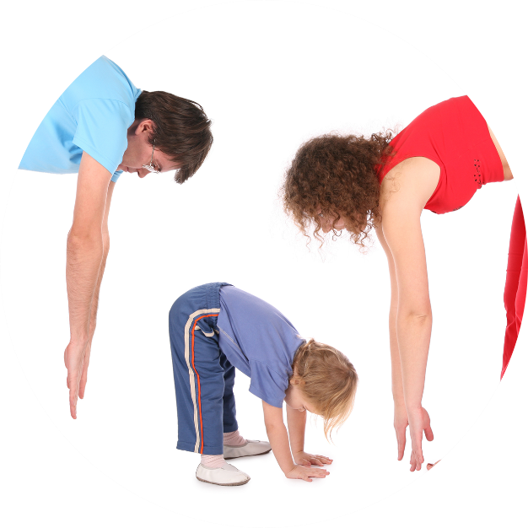
- Workout movements can be seen on the videos so you can learn the new exercise and practice it well. Starting slowly with a focus on technique will enable you to go faster and stronger later.
- Stretches are less likely to cause injury when done after warm-ups. Use a slower piece of music to do stretches. Stretch gently – and hold for 5 seconds.
- Rest and recover after energetic movement. Conversation is great here.
- "Tap out" is a way to pass the exercise on to the next person. You can choose different ways to “tap out” e.g. hand clap, whistle, finger guns, wink etc. You make it up!

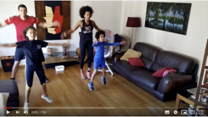
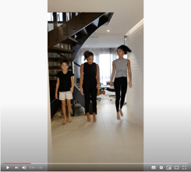
Promotional video
Video links
Find all the videos for family.fit at https://family.fit/ or at the family.fit YouTube® channel
family.fit mobile video
family.fit video

Please Stay Connected
We hope you have enjoyed this booklet of family.fit. This has been put together by volunteers from around the world. You will find all new family.fit sessions on the website https://family.fit
The website has the latest information, ways you can feedback your thoughts and is the place to stay connected with family.fit!
If you enjoyed this, please share with your friends and others you know who might like to participate.
This resource is given freely and meant to be freely given to others at no cost.
If you translate this into your language, please share it back on the website or email it to info@family.fit so it can be shared with others.
Thank you.
The family.fit team

Web: www.family.fit
Email: info@family.fit

