Do I wonder about life?
9
Week
Help your family be fit and healthy, stay connected, and grow in character.
A vaccine for isolated days!
family.fitness.faith.fun
www.family.fit
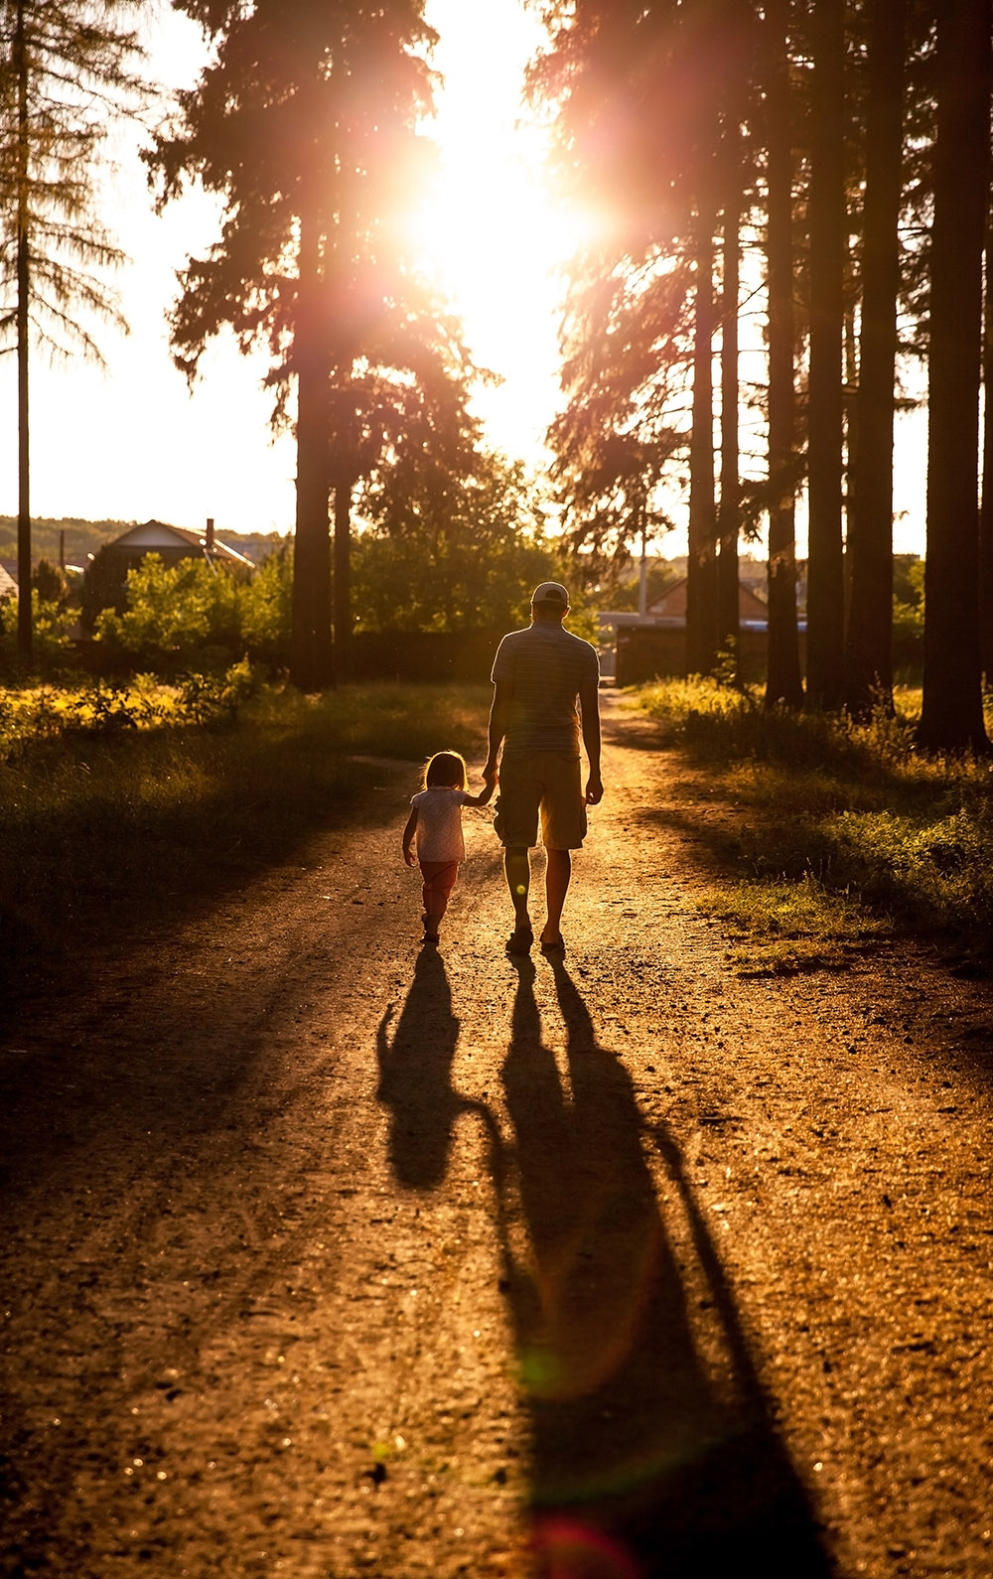

How to make fitness an important part of your family’s life:

Make it fun
Do exercise a few times a week.
Find a time that will work for everyone.
- Be active together
- Play games
- Involve everyone in the household
- Go inside or outside
- Be creative and improvise with what you have

#1: Take a photo of your family enjoying family.fit and post on social media. Tag with #familyfit
#2: Think of a family who has never done family.fit. Do it together on Zoom® or WhatsApp® video.

Two great ideas

Challenge each other
- Allow different levels of challenge according to ability, size and age
Set personal goals.
Compare improvements with your personal best.
- Respect each other
- Listen actively
- Share family.fit! It’s free.
- Don’t do exercises that cause pain or make any existing pain worse.
- Don’t exercise if you are sick. Wash hands before and after family.fit.
IMPORTANT AGREEMENT BEFORE USING THIS RESOURCE
By using this resource you agree to our Terms and Conditions https://family.fit/terms-and-conditions/ as detailed in full on our website. These govern your use of this resource by you and all those exercising with you. Please ensure that you and all those exercising with you accept these terms and conditions in full. If you disagree with these terms and conditions or any part of these terms and conditions, you must not use this resource.

How this works
As a family, do some physical exercise 3 days a week (though even once is helpful!). If you can do it more often, then do other types of exercise too – walking, jogging, riding, skating, or swimming.
Each week of family.fit has a theme. The focus this week is wondering. Each step below helps you explore the theme together.
7 steps of family.fit

- Warm-up
- Talk
- Move
- Challenge
- Explore
- Pray
- Play

Each session is an adventure made up of 7 steps.
There are 3 options for each step, giving 3 days of exercise programming.
Remember anyone in the household can take the phone and lead a different step in the adventure.
Have fun together!
Watch this video
Theme: Wondering
This Week
Step 1: Warm-up
Start moving the whole body: 5 minutes

Do the following whole-body warm-ups
Day 1 — Warm-up to music
Do the following for 60 seconds each:
- High knees running
- High knees to side
- Scissor jumps
- Jumping jacks
Watch this video
Day 2 — Junkyard dog
One person sits on the floor with legs out to the front and arms out to the side. The others jump over the arm, the legs and the second arm. Everybody jumps two rounds and changes places so everybody gets to jump.
Watch this video
Day 3 — Warm-up to music
Repeat Day 1.
Step 2: Talk together
Rest and start a conversation: 5 minutes

Sit down together and start a short conversation. Here are some questions to get you started.
Day 1 — Discuss
How do you feel when you look at the night sky?
How many stars do you think are in the universe?
What is the biggest number you can think of?
Wonder together why God made so many stars.
Day 2 — Discuss
Think of a famous person and share what you like about them.
Do they know who you are?
Who are the people who care about you, and know what makes you special?
Day 3 — Discuss
Do you have a pet animal or would you like one?
Do you have a garden or would you like one?
What responsibilities are involved in having a pet or a garden?

Step 3: Move
Move and do speed skaters: 5 minutes

Practice the speed skaters movement to develop leg and core strength.
Day 1 — Practice speed skaters
Practice speed skaters. Do 10 of them. Rest and then do 20. Rest, then do 30.
Watch this video.
Day 2 — Tabata
Do as many speed skaters as you can for 20 seconds, rest 10 seconds, and then repeat 8 times.
Try and do the same number in each round.
Listen to tabata music
Day 3 — Harder speed skaters
Practice harder speed skaters. Make them smooth and increase speed. Do 20. Rest and then do 20 again.
Try 20 speed skaters over an object. Rest and then do 20 again.
Watch this video.

Step 4: Challenge
Move in a family challenge: 10 minutes

Challenging each other helps give you energy.
Day 1 — Obstacle course
Set up an obstacle course. Use the space you have inside or outside (e.g. run to the tree/chair, leap over the path/rug, etc.) Be creative!
Take turns to get through the obstacle course as quickly as possible. Time each person.
Watch this video.
Day 2 — Knee tag
Compete in pairs. Try to touch your opponent’s knees as many times as you can in 60 seconds while you protect your own with your hands and body position. Change partners.
Watch this video.
Day 3 — Family challenge
Stand in a circle. Do 100 speed skaters as a family. One person starts and then taps out to the next person when needed. After 100, rest for 30 seconds and then start speed skaters again.
Three rounds of 100.

Step 5: Explore
Explore the Bible together: 5 minutes

Explore the Life Question - ‘Do I wonder about life?‘ Read Psalm 8.
Day 1 — Read Psalm 8 and talk
Set a timer for 60 seconds and see who can draw the most stars in that time. What is your family total?
If you counted all the stars, one per second, it would take more than a trillion years! What does this tell you about our Creator God?
Day 2 — Reread and talk
The Psalm says God thinks about us and cares for us. Think: I wonder what God is thinking about us today?
Knowing that God cares for and notices you, how does it make you feel? Add words to finish this sentence ‘I feel…‘ and make a poster together.
Day 3 — Reread and talk
From the Psalm, what responsibilities does God give to humans?
Do you think humans are doing a good job of taking care of everything God made? (Consider verses 7-8).
What is one small or big thing you could do to help?

Do I wonder about life?
The following passage is a song written by King David about 3000 years ago. Even though he was a king, he felt both small and special when he compared himself to God and what He has created. If you want to read more look in a Bible or visit YouVersion.
Lord our Lord, your name is the most wonderful in all the earth! It brings you praise everywhere in heaven.
From the mouths of children and babies come songs of praise to you. They sing of your power to silence your enemies who were seeking revenge.
I look at the heavens you made with your hands. I see the moon and the stars you created.
And I wonder, why are people so important to you?
Why do you even think about them?
Why do you care so much about humans?
Why do you even notice them?
But you made them almost like gods and crowned them with glory and honor.
You put them in charge of everything you made. You put everything under their control.
People rule over the sheep and cattle and all the wild animals.
They rule over the birds in the sky and the fish that swim in the sea.
Lord our Lord, your name is the most wonderful name in all the earth!
Psalm 8

Step 6: Pray
Pray and cool down: 5 minutes

Take time to look outwards and pray for others.
Day 1 — Pray and stretch
While you stretch, take turns sharing something that makes you think of how big and great our God is (like a big mountain or wide ocean) and tell Him how great He is!
Day 2 — Pray and wonder
God is big enough to cope with our wondering questions. Finish today by sharing some of your ‘I wonder why…’ questions.
Day 3 — Pray Psalm 8 together
Read Psalm 8 out loud together as a prayer of praise to God.

Step 7: Play together
Play games as a family: 5 minutes

Play together in active challenges. Have fun!
Day 1 — Mirror mirror
Stand face to face with a partner and have them attempt to copy all your movements. Make it fun. Then swap roles.
Watch this video.
Day 2 — Sharks
Scatter some ‘islands‘ and ‘boats‘ across the floor (use pillows, stuffed animals, towels etc) and then have everyone jump from one to the next without falling into the water and risk being eaten by ‘sharks’.
Watch this video.
Day 3 — Make an ‘I wonder’ book
Create an ‘I wonder‘ book. Let everyone store their big ideas and curious questions in a note book. Maybe research some answers together. Encourage kids to continue to ask questions ever though some answers may be hard to investigate.
Terminology
- A warm-up is a simple action that gets muscles warm, breathing deeper, and blood pumping. Play fun, up-tempo music for your warm-up activities. Do a range of movements for 3-5 minutes.
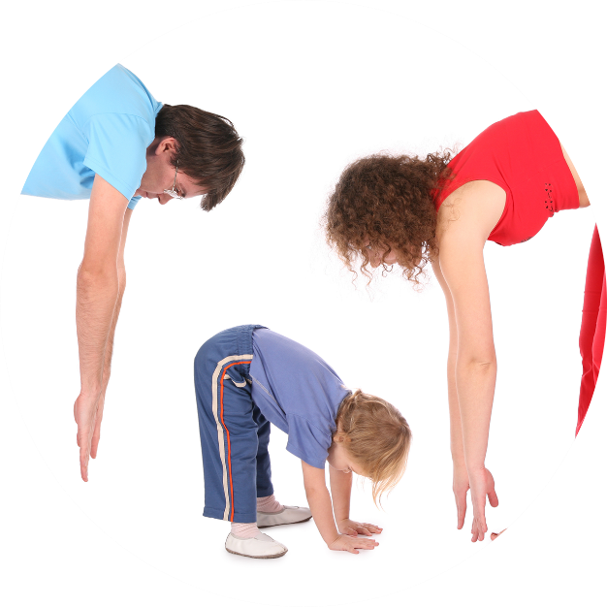
- Workout movements can be seen on the videos so you can learn the new exercise and practice it well. Starting slowly with a focus on technique will enable you to go faster and stronger later.
- Stretches are less likely to cause injury when done after warm-ups. Use a slower piece of music to do stretches. Stretch gently – and hold for 5 seconds.
- Rest and recover after energetic movement. Conversation is great here.
- ‘Tap out‘ is a way to pass the exercise on to the next person. You can choose different ways to ‘tap out‘ e.g. hand clap, whistle, finger guns, wink etc. You make it up!

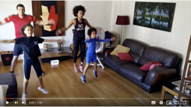
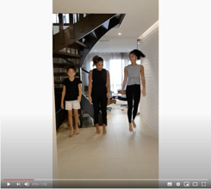
Promotional video
Video links
Find all the videos for family.fit at https://family.fit/ or at the family.fit YouTube® channel
family.fit mobile video
family.fit video

Please Stay Connected
We hope you have enjoyed this booklet of family.fit. This has been put together by volunteers from around the world. You will find all new family.fit sessions on the website https://family.fit.
The website has the latest information, ways you can feedback your thoughts and is the place to stay connected with family.fit!
If you enjoyed this, please share with your friends and others you know who might like to participate.
This resource is given freely and meant to be freely given to others at no cost.
If you translate this into your language, please share it back on the website or email it to info@family.fit so it can be shared with others.
Thank you.
The family.fit team

Web: www.family.fit
Email: info@family.fit

