family.fitness.faith.fun

Who do I trust?

A vaccine for isolated days!
Help your family be fit and healthy, stay connected, and grow in character.
11
WEEK

www.family.fit

How to make fitness
an important part of your family’s life:

Make it fun
- Be active together
Do exercise a few times a week.
Find a time that will work for everyone.

- Play games
- Involve everyone in the household
- Go inside or outside
- Be creative and improvise with what you have

Two Great Ideas
#2: Think of a family who has never
done family.fit.
Do it together
on Zoom® or WhatsApp® video.

#1: Take a photo
of your family doing family.fit together and post on social media. Tag with #family.fit

Challenge each other
- Allow different levels of challenge according to ability, size and age
Set personal
goals.
Compare improvements with your personal best.
- Respect each other
- Listen actively
- Share family.fit! It’s free.
- Don’t do exercises that cause pain or make any existing pain worse.
- Don’t exercise if you are sick. Wash hands before and after family.fit.
IMPORTANT AGREEMENT BEFORE USING THIS RESOURCE
By using this resource you agree to our Terms and Conditions https:/family.fit/terms-and-conditions/ as detailed in full on our website. These govern your use of this resource by you and all those exercising with you. Please ensure that you and all those exercising with you accept these terms and conditions in full. If you disagree with these terms and conditions or any part of these terms and conditions, you must not use this resource.

This Week

Theme: Trust
How this works
As a family, do some physical exercise 3 days a week (though even once is helpful!). If you can do it more often, then do other types of exercise too – walking, jogging, riding, skating, or swimming.
Each week of family.fit has a theme. The focus this week is on trust. Each step below helps you explore the theme together.
Each session is an adventure made up of 7 steps.
There are 3 options for each step, giving 3 days of exercise programming.
7 Steps of family.fit
- Warm-up
- Talk
- Move
- Challenge
- Explore
- Pray
- Play

Remember anyone in the household can take the phone and lead a different step in the adventure.
Have fun together!
Watch video

Step 1 | Warm-up

Start moving the whole body 5 minutes
Do the following whole body warm-ups.
Corners warm-up
DAY 1
Label the corners of the room with the numbers 1-4. Each person starts at a different corner and does a different warm-up. Move around the room to the next number. Two rounds.
Watch video
- 10 Jumping jacks
- 10 Butt kicks
- 10 High plank to low plank
- 10 Squats

Follow the leader
DAY 2
2
One person is leader for each round. Start by jogging around. The leader says a name and the family must move like this. Mix them up.
Watch video
Mr. Slow - move slowly
Mr. Rush - move fast
Mr. Jelly - shake your whole body
Mr. Muddle - walk backwards
Mr. Bounce - hop around
Mr. Small - crouch and keep moving
Mr. Strong - move flexing your muscles
Mr. Tall - stretch up and move
Mr. Tickle - wave your arms around
Mr. Happy - move and smile
Corners warm-up
DAY 3

Repeat day 1.

Step 2 | Talk together

Rest and start a conversation 5 minutes
Sit or stand together and start a short conversation. Here are some questions to get you started.
Discuss
DAY 1
It’s very special to have people you can trust. Who would you trust to keep a secret? To help you in trouble? To defend you if other people were giving you a hard time?
Discuss
DAY 2
2
Have you ever been let down by people you trusted? What did that feel like at the time? What does it feel like now?
Discuss
DAY 3

What makes a group of people trustworthy? Do you think that you’re the kind of family that other families would trust? Why?

Step 3 | Move

Move and squat 5 minutes
Practice squats to develop leg and core strength.
Practice squats
DAY 1
Practice this movement in pairs. Start with 10 squats and take a short rest. Then do rounds of 15, 20 and 25.
Watch video
Scaled squats
DAY 2
2
Easier version: Sit on a chair and stand up. Do 20 repetitions.
Harder version: Jump Squat – Go down as a regular squat but rise up into a jump. Do 20 repetitions.
Watch video
Squats and planks
DAY 3

Work in pairs. One person does 20 squats while the other stays in a plank position. Alternate between squats and a plank. Complete three rounds.
Watch video

Step 4 | Challenge

Move in a family challenge 10 minutes
Challenging each other helps give you energy.
Unity squat
DAY 1
Stand in a circle holding hands.
Complete 10 squats together. Rest 15 seconds. Repeat.
Complete four rounds if you can. At the end, give a high five to everyone.
Watch video
Throw the dice
DAY 2
2
Find or make a dice. Complete 80 squats as a family (or more). Each person rolls the dice and does that number of squats. Keep a total count.
Tic-tac-toe
DAY 3

Work in two teams. Each team is given a challenge. For example, 10 squats or superman holds. When completed, two people run and place their piece on the tic-tac-toe game. Continue with new challenges.
Watch video

Step 5 | Explore

Explore the Bible together 5 minutes
Explore the Life Question – “Who do I trust?” Read Acts 16:25-34 (see next page).
Read and talk
DAY 1
Read the story. What things surprise you? How would you feel as a prisoner in a crowded cell? How would you react when Paul and Silas start singing and praying? Why do you think they still trust God when they have been imprisoned?
Reread and act it out
DAY 2
2
Choose roles and act out the story.
The jailer is terrified when he thinks everyone has escaped. Why did he trust Paul and Silas when he hardly knew them? If someone asked you: ‘What must I do to really live?’, what would you say?
Reread and talk
DAY 3

The jailer and his family put their trust in Jesus. Can you think of some Gospel stories Paul and Silas might have shared about Jesus that convinced them He was trustworthy?

Scripture about who to trust
The following story comes from chapter 16 of the Book of Acts in the Bible. Paul and Silas are followers of Jesus. They were put in prison by people who were afraid of them. If you want to read more visit BibleGateway (or Bible App).
About midnight, Paul and Silas were at prayer and singing … to God. The other prisoners couldn’t believe their ears. Then, without warning, a huge earthquake! The jailhouse tottered … all the prisoners were loose. Startled from sleep, the jailer saw all the doors swinging loose on their hinges. Assuming that all the prisoners had escaped, he pulled out his sword and was about to do himself in … when Paul stopped him: “Don’t do that! … Nobody’s run away!”
The jailer got a torch and ran inside. Badly shaken, he collapsed in front of Paul and Silas … and asked, “Sirs, what do I have to do to be saved, to really live?” They said, “Put your entire trust in the Master Jesus. Then you’ll live as you were meant to live!”… They went on to spell out in detail the story of the Master—the entire family got in on this part … It was a night to remember: He and his entire family had put their trust in God; everyone in the house was in on the celebration.
Acts 16:25-34 MSG (abridged)

Step 6 | Pray

Pray and cool down 5 minutes
Take time to look outwards and pray for others.
Pray and send a thank you
DAY 1
Thank God for the people you are able to trust. Send them a thank you message so they know you appreciate them.
It might be you!
DAY 2
2
Some people at your school, workplace, or in your neighborhood may have no one they can turn to when they need help. Pray that they will find a trustworthy person. It might be you!
Celebrate in song
DAY 3

Celebrate the trustworthiness of God by creating a song of thanksgiving. Get contributions from everyone in the family. Record it and send it to a friend or family.

Step 7 | Play together

Play games as a family 5 minutes
Play together in active challenges. Have fun!
Egg race
DAY 1
Make a short obstacle course. In pairs stand with a boiled egg or other small object between your foreheads. Carry it through the course and back (no hands). If you drop it you must restart the race.
Trust walk
DAY 2
2
Work in pairs. One person is blindfolded while the other gives instructions to get to a goal. Put some obstacles out to make it more challenging.
Watch video
Back to back drawing
DAY 3

Sit in pairs back to back. One person has a simple picture and must give instructions to the other to draw it. Don’t show the picture or say what it is.

Terminology
- A warm-up is a simple action that gets muscles warm, breathing deeper, and blood pumping. Play fun, up-tempo music for your warm-up activities. Do a range of movements for 3-5 minutes.
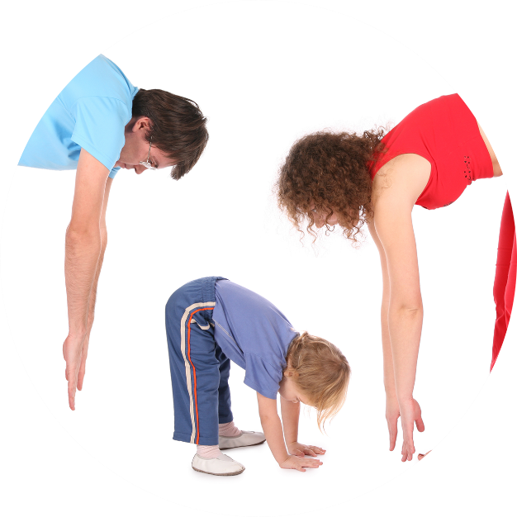
- Workout movements can be seen on the videos so you can learn the new exercise and practice it well. Starting slowly with a focus on technique will enable you to go faster and stronger later.
- Stretches are less likely to cause injury when done AFTER warm-ups. Use a slower piece of music to do stretches. Stretch gently – and hold for 5 seconds.
- Rest and recover after energetic movement. Conversation is great here.
- Tap out is a way to pass the exercise on to the next person. You can choose different ways to “tap out” e.g. hand clap, whistle, finger guns, wink etc. You make it up!

Video links
Find all the videos for family.fit at https://family.fit/ or at the family.fit YouTube® channel

family.fit promo video
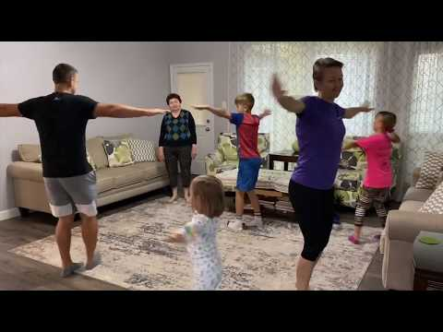
family.fit video
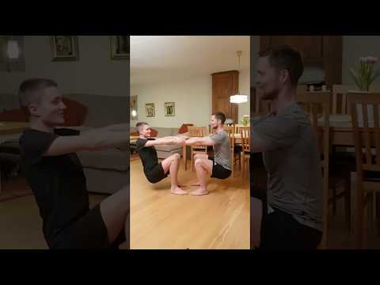
family.fit mobile video

Please Stay Connected
We hope you have enjoyed this booklet of family.fit. It has been put together by volunteers from around the world. You will find all new family.fit sessions on the website https://family.fit
The website has the latest information, ways you can feedback your thoughts and is the place to stay connected with family.fit!
If you enjoyed this, please share with your friends and others you know who might like to participate.
This resource is given freely and meant to be freely given to others at no cost.
If you translate this into your language, please share it back on the website or email it to info@family.fit so it can be shared with others.
Thank you.
The family.fit team

- ourage.

Web: www.family.fit
Email: info@family.fit
Web: www.family.fit
Email: info@family.fit

