family.fitness.faith.fun

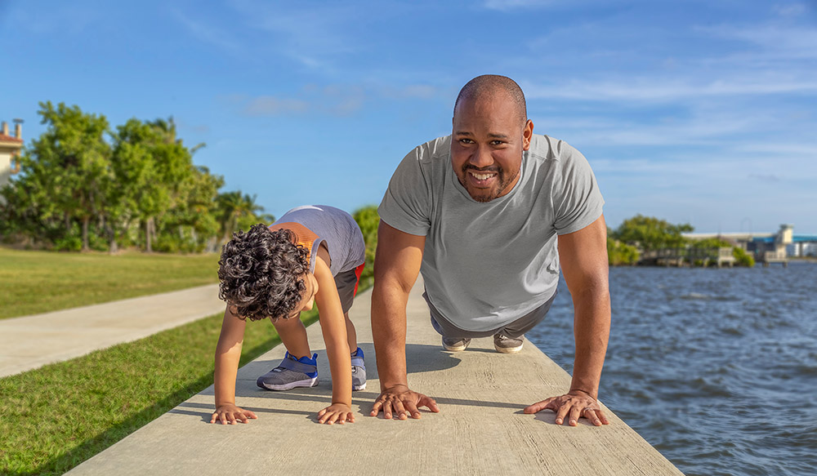

Does my life reflect discipline?

A vaccine for isolated days!
Help your family be fit and healthy, stay connected, and grow in character.
12
WEEK

www.family.fit

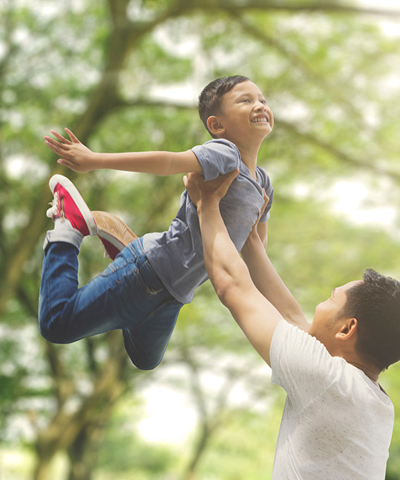

How to make fitness
an important part of your family’s life:

Make it fun
- Be active together
Do exercise a few times a week.
Find a time that will work for everyone.

- Play games
- Involve everyone in the household
- Go inside or outside
- Be creative and improvise with what you have

Two Great Ideas
#2: Think of a family who has never
done family.fit.
Do it together
on Zoom® or WhatsApp® video.

#1: Take a photo
of your family doing family.fit together and post on social media. Tag with #family.fit

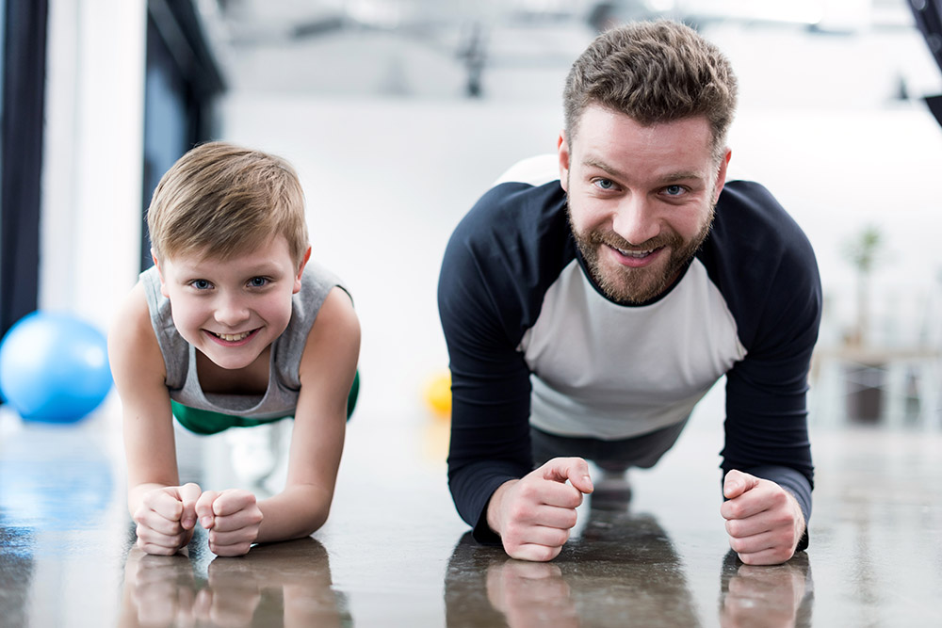

Challenge each other
- Allow different levels of challenge according to ability, size and age
Set personal
goals.
Compare improvements with your personal best.
- Respect each other
- Listen actively
- Share family.fit! It’s free.
- Don’t do exercises that cause pain or make any existing pain worse.
- Don’t exercise if you are sick. Wash hands before and after family.fit.
IMPORTANT AGREEMENT BEFORE USING THIS RESOURCE
By using this resource you agree to our Terms and Conditions https:/family.fit/terms-and-conditions/ as detailed in full on our website. These govern your use of this resource by you and all those exercising with you. Please ensure that you and all those exercising with you accept these terms and conditions in full. If you disagree with these terms and conditions or any part of these terms and conditions, you must not use this resource.

This Week

Theme: Discipline
How this works
As a family, do some physical exercise 3 days a week (though even once is helpful!). If you can do it more often, then do other types of exercise too – walking, jogging, riding, skating, or swimming.
Each week of family.fit has a theme. The focus this week is on discipline. Each step below helps you explore the theme together.
Each session is an adventure made up of 7 steps.
There are 3 options for each step, giving 3 days of exercise programming.
7 Steps of family.fit
- Warm-up
- Talk
- Move
- Challenge
- Explore
- Pray
- Play

Remember anyone in the household can take the phone and lead a different step in the adventure.
Have fun together!

Watch video

Step 1 | Warm-up

Start moving the whole body 5 minutes
Do the following whole body warm-ups.
Corner warm-up
DAY 1
Everyone runs on the spot in a different corner of the room. One person runs to the diagonal corner and taps that person who runs to another corner. Continue for two minutes.
Watch video
Run on the line
DAY 2
2
Line up next to each other.
Jump once at the starting point and jog to the midway point.
At the midway point, jog backwards to the starting point.
Jump once and jog to the finish line. Jump again and jog backwards to the midway point and then back to the finish line.
Jog back the starting point and repeat. Watch video
Corner warm-up
DAY 3

Repeat day 1 with high knees.

Step 2 | Talk together

Rest and start a conversation 5 minutes
Sit or stand together and start a short conversation. Here are some questions to get you started.
Discuss
DAY 1
Have you ever done well in sport, school, work or friendship? How did you feel when success was unexpected? When you tried hard to do well?
Discuss
DAY 2
2
Choose one or two family goals for the year. For example: walk three days/week, do a favor for a neighbor, learn a new recipe. How might you need to ‘strain toward' them?’ Who will keep you focused?
Discuss
DAY 3

You’ll need to be disciplined to reach your family goal. What are some things you can do to make sure you’re not distracted? Are some sacrifices required?

Step 3 | Move

Move and do down-ups 5 minutes
Practice down-ups to develop leg and core strength.
Practice down-ups
DAY 1
With hands and feet on the ground, walk or jump feet backwards so your body is in a straight line. Walk or jump feet up close to your hands and then stand up and clap your hands over your head.
Try five down-ups and then rest. Repeat three times. Watch video
Down-ups
DAY 2
2
Do five down-ups and tap to the next person. Continue until you have completed 50. Watch video
Paired down-ups
DAY 3

One pair does five down-ups together then taps out to another pair. Repeat. Try to do as many down-ups in 90 seconds as you can. Watch video

Step 4 | Challenge

Move in a family challenge 10 minutes
Challenging each other helps give you energy.
Family challenge
DAY 1
Write labels for the six movements below (one per card) and place in a circle. One person spins a bottle and does the movement it points to. Tap to the next family member.
Challenge: 120 movements as a family. 5 lunges, 5 down-ups, 5 push-ups, 10 squats, 10 sit-ups, 10 high knees running.
Color relay
DAY 2
2
Choose a favorite color together. Each person must run and collect five pieces of clothing or objects of that color, one piece at a time, and bring it back to the starting point. Race against the clock.
Knee tag
DAY 3

Compete in pairs. Try to touch your opponent’s knees as many times as you can in 60 seconds while you protect your own with your hands and body position. Change partners. Watch video

Step 5 | Explore

Explore the Bible together 5 minutes
Explore the Life Question – “Does my life reflect discipline?” Read 2 Timothy 2:5 and Philippians 3:13-17 (see next page).
Read and talk
DAY 1
In Paul’s time, athletics was popular. To win, you had to be disciplined by training hard and keeping the rules. What rules in your family and neighborhood are not written down? What happens if they’re broken? Why do we have rules?
Reread and act out
DAY 2
2
We all make mistakes. Paul had to 'forget what is behind.’ What mistake of yours is hard to 'forget’? Those mistakes can stop us from being focussed. What restoration is needed to help you move on?
Reread and talk
DAY 3

Paul says the best prize is to know Jesus well. This requires discipline. Why do you think this was this Paul’s top goal? What's your top goal in life? Will it help you and others?

Scripture about being disciplined
The following verses come from two letters in the Bible written by the Apostle Paul. If you want to read them look in a Bible or visit BibleGateway (or download the Bible App).
Paul wrote these words to a young friend called Timothy to encourage him to stay focused on Jesus:
“Anyone who competes as an athlete does not receive the victor’s crown except by competing according to the rules.”
2 Timothy 2:5 NIV
And he wrote these words to the church in Philippi:
“But one thing I do: Forgetting what is behind and straining toward what is ahead, I press on toward the goal to win the prize for which God has called me heavenward in Christ Jesus …. Join together in following my example, brothers and sisters, and just as you have us as a model, keep your eyes on those who live as we do.”
Philippians 3:13-17 NIV (Abridged)

Step 6 | Pray

Pray and cool down 5 minutes
Take time to look outwards and pray for others.
Pray and stretch
DAY 1
Sit quietly. Think about times you’ve deliberately broken rules – even if no one has noticed. Tell God about them. If you’re sorry, ask Him to forgive you and help you to change. He will!
Sorry note
DAY 2
2
Each person takes a piece of paper. Write or draw about a mistake you made that hurt someone. Have courage to say sorry. Then tear the paper into pieces and say “it’s over”. ‘Press on’ and find a way to be a positive example to them and others.
Pray to grow
DAY 3

Share an idea from this week's Bible reading that impacted you, and say how it will help you if you implement it. This could be your goal for the week. Now it’s time for self-discipline!

Step 7 | Play together

Play games as a family 5 minutes
Play together in active challenges. Have fun!
Spider web
DAY 1
Make a spiderweb obstacle with string or ribbon. Design it so there are spaces to get through the spider’s web. Now as a family, help each other get through the spider web without touching the string.
Red light green light
DAY 2
2
Everyone stands at one end of the room. The ‘caller’ stands at the side. When the caller says “green light” everyone moves towards the finish line. When they say “red light” everyone must stop. If someone is moving they go back to the starting line.
Watch video
Follow my clap
DAY 3

Someone creates a clapping pattern. Everyone listens carefully and follows the pattern. Take turns to lead.

Terminology
- A warm-up is a simple action that gets muscles warm, breathing deeper, and blood pumping. Play fun, up-tempo music for your warm-up activities. Do a range of movements for 3-5 minutes.
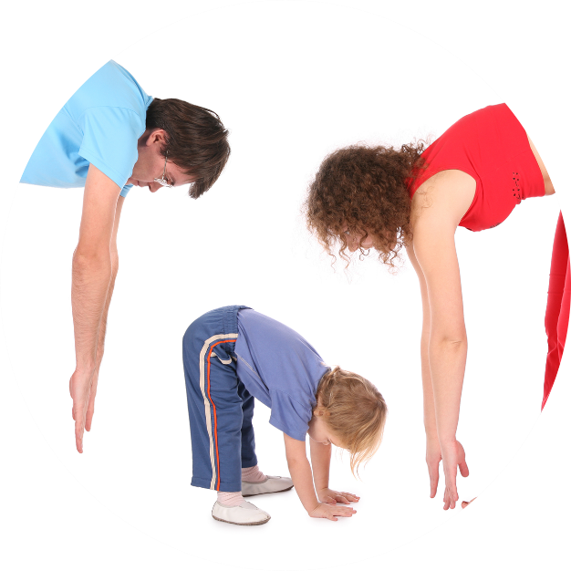
- Workout movements can be seen on the videos so you can learn the new exercise and practice it well. Starting slowly with a focus on technique will enable you to go faster and stronger later.
- Stretches are less likely to cause injury when done AFTER warm-ups. Use a slower piece of music to do stretches. Stretch gently – and hold for 5 seconds.
- Rest and recover after energetic movement. Conversation is great here.
- Tap out is a way to pass the exercise on to the next person. You can choose different ways to “tap out” e.g. hand clap, whistle, finger guns, wink etc. You make it up!

Video links
Find all the videos for family.fit at https://family.fit/ or at the family.fit YouTube® channel

family.fit promo video
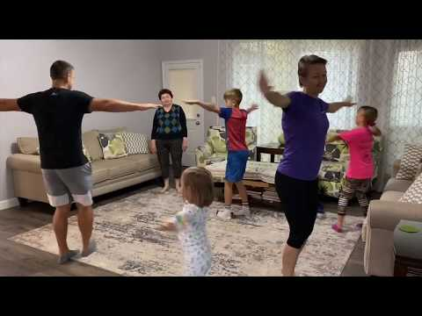
family.fit video
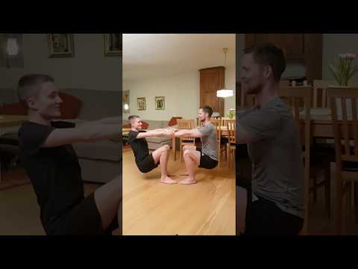
family.fit mobile video

Please Stay Connected
We hope you have enjoyed this booklet of family.fit. It has been put together by volunteers from around the world. You will find all new family.fit sessions on the website https://family.fit
The website has the latest information, ways you can feedback your thoughts and is the place to stay connected with family.fit!
If you enjoyed this, please share with your friends and others you know who might like to participate.
This resource is given freely and meant to be freely given to others at no cost.
If you translate this into your language, please share it back on the website or email it to info@family.fit so it can be shared with others.
Thank you.
The family.fit team

- ourage.

Web: www.family.fit
Email: info@family.fit
Web: www.family.fit
Email: info@family.fit

