family.fitnes s.faith.fun

Celebration Week

Help your family be fit and healthy, stay connected, and grow in character.
End of Season 1 (Week 13)
Look out for the next season of family.fit
www.family.fit

This Week: Celebration
Congratulations!
You have finished the first season of family.fit.
Watch out for other seasons coming in a new, easy to use format.
We hope you can see changes in your family. Perhaps you are healthier and fitter. Maybe you are more positive and more connected. Perhaps you have had a breakthrough as a family in forgiveness or communication, kindness or courage.
Let’s celebrate what God is doing!
If you can, get together with other families. Let’s combine fitness, faith, fun and food, and celebrate before we start the next season of family.fit.
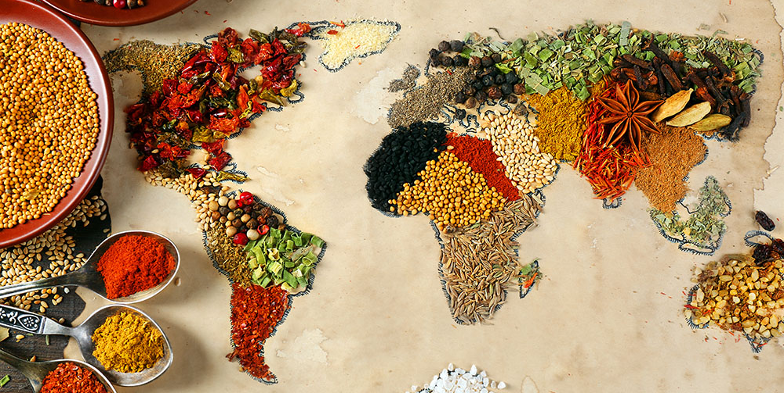

Celebration ideas
Meet together as a family. Look at these ideas and come up with a plan to celebrate finishing the first season of family.fit.
Design the event to suit your current situation. If you’re in lockdown, try and connect in creative ways.
Include these elements:
- 1. Families in your neighborhood
- 2. Fitness
- 3. Fun
- 4. Faith
- 5. Food
Choose ideas from the following pages to get started.

IMPORTANT AGREEMENT BEFORE USING THIS RESOURCE
By using this resource you agree to our Terms and Conditions https:/family.fit/terms-and-conditions/ as detailed in full on our website. These govern your use of this resource by you and all those exercising with you. Please ensure that you and all those exercising with you accept these terms and conditions in full. If you disagree with these terms and conditions or any part of these terms and conditions, you must not use this resource.

1. Other Families
Invite other families
Think of some other families you can get together with to celebrate. They could be people who have done family.fit or people who could start next season.
If you cannot come together face to face, then connect over Zoom® or Skype® or out your window.
Pray for them
Pray for the other families you invite. Invite someone isolated or elderly. They would love to be part of your family for the celebration.
Make invitations
Make the invitations fun. You could make a fun video message. You could draw and write an invitation card. You could set a challenge to the other family.

2. Fitness
Choose some fitness elements
Look over the past 12 weeks of fitness and pick 3 different challenges you can do with other families.
Here are some ideas to get you started:
WATCH: Obstacle course
WATCH: Relay
WATCH: Superman roll
Make up a challenge
Each family who has done family.fit could make up a challenge to show the other families. Use at least 2 movements in the challenge.
Design a competition
Take one of the challenges and make it competitive. It could be children versus parents or male versus female. It could be family versus family. Think what would work best and be fun.

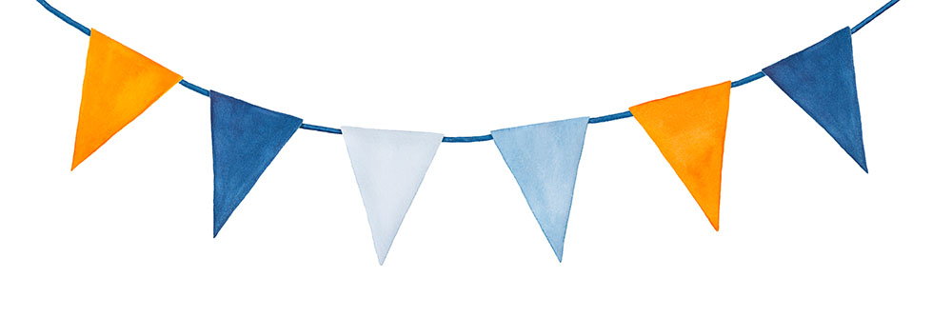
3. Fun

Decorations
Choose a venue for your celebration. It might be a park, your home or a hall. Now make it look fun and special. Be creative!
Fun games and sports
Plan for some fun games that everyone knows and loves. For example, frisbee, football, cricket or tag.
Choose a family.fit game
Think back over the last 12 weeks and choose some games to play that involve everyone. Here are some ideas to get you started:
WATCH: Tic-tac-toe
WATCH: Around the world table tennis
WATCH: Tail competition

4. Faith
Share how you have grown
Share with other families how your family has grown and changed in the last months. What positive things are happening? What have you learned?
Open the Bible together
Choose a theme that really helped your family. Read this scripture again and complete some of the activities and questions with other families.
Watch a Max7 video together
Look at one of these videos and discuss the themes (see Max7.org):
Wise and foolish builders
The Lost sheep
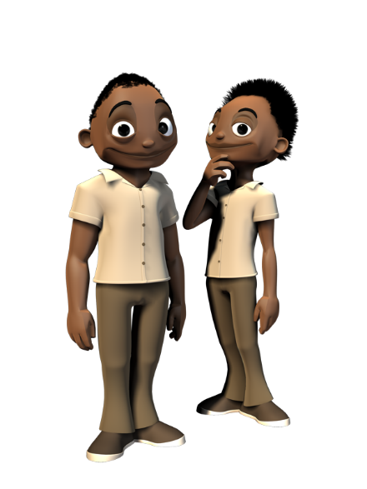
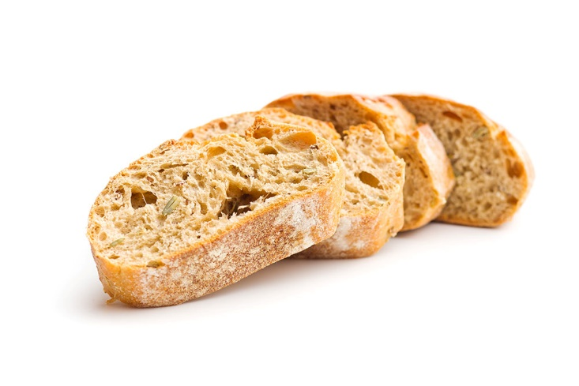

5. Food
Every family bring a meal
Each family bring a favorite meal to share with other families. If you can’t meet together, share a favorite recipe with other families.
Prepare healthy food together
Find some simple recipes for some healthy foods and drinks to make together.
For example:
Make a drink using fresh fruit
Make a healthy snack
Cook a meal together
Have a barbecue, make a curry or other home cooked meal where families bring ingredients to cook together.

A new look family.fit is coming
Season 2 will start in Week 14. This is a new family.fit season to help you to continue to grow your family, your fitness, your faith and your fun!
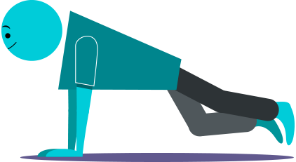
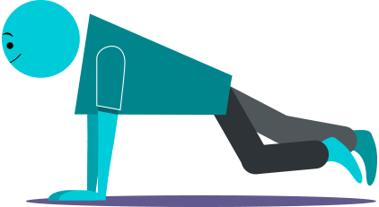
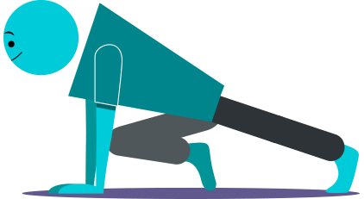
All new
SEASON 2

Things to look forward to:
A simpler layout with 5 steps.
New design and easier layout.
Smaller files to be able to share.
Great new fitness activities and challenges.
New engaging Bible discussions.

Video links
Find all the videos for family.fit at https://family.fit/ or at the family.fit YouTube® channel

family.fit promo video
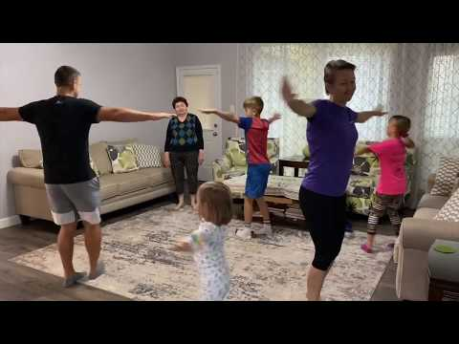
family.fit video
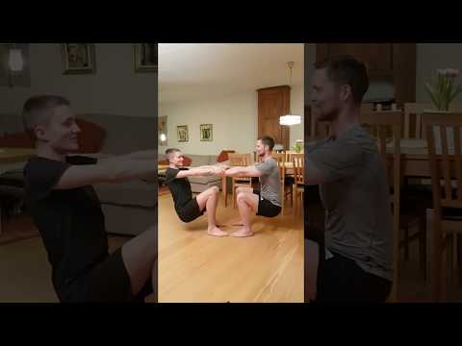
family.fit mobile video

Please Stay Connected
We hope you have enjoyed this booklet of family.fit. It has been put together by volunteers from around the world. You will find all new family.fit sessions on the website https://family.fit
The website has the latest information, ways you can feedback your thoughts and is the place to stay connected with family.fit!
If you enjoyed this, please share with your friends and others you know who might like to participate.
This resource is given freely and meant to be freely given to others at no cost.
If you translate this into your language, please share it back on the website or email it to info@family.fit so it can be shared with others.
Thank you.
The family.fit team

- ourage.

Web: www.family.fit
Email: info@family.fit
Web: www.family.fit
Email: info@family.fit

